3. Handling Filelist
The Filelist is used as storage for files that will be used on the website. Here you can create your own folder structure, upload new files and also overwrite them.
Recommendation: all files should be uploaded to Filelist. This is not possible if an image has been uploaded into an element, directly from the local computer, because, for example, if an element or page is accidentally deleted, and the files have been linked in from Filelist, TYPO3 will be able to restore the content.

3.1 Create folders
"Filelist" in the left hand menu (Img. 3.1.1) accesses the Folder structure where all files should be stored for working in TYPO3.
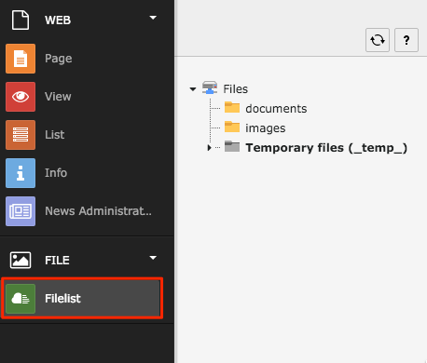3.1.1
To create a new folder, right-click on an existing folder (or click on the folder icon on the left side of the folder title) and select "New" in the menu that appears. Please note that the folders are created as subfolders to the one you clicked on. (Img. 3.1.2)
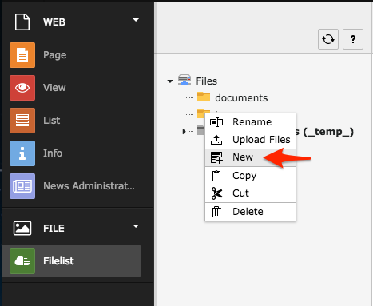3.1.2
By using the drop down (1) you can create up to 10 folders at a time (Img. 3.1.3). Type in the titles of the folder, one field for each folder of the amount of folders you have selected (2). Then click "Create folders" and a new folders will appear in the Filelist.
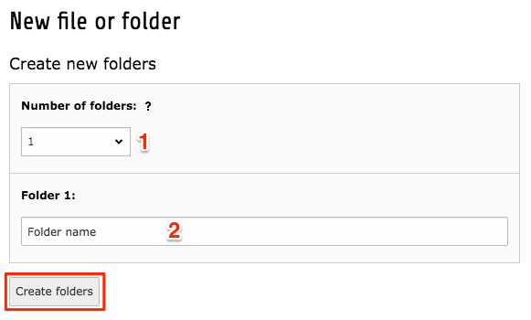3.1.3

3.2 Delete folder
To delete a folder, right-click (or click on the folder icon) to access the menu and then select "Delete". Folders which contains files cannot be deleted, you must first delete all files in the folder. (Img. 3.2.1)
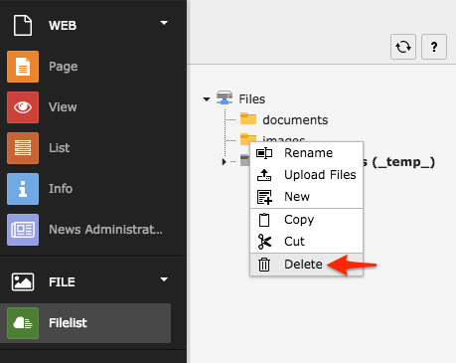3.2.1

3.3 Upload files
There are 3 different ways to upload files: by dragging and dropping files, through the upload icon or by using the folder menu.
Here are detailed descriptions how to use them:

Dragging and dropping files
Select a folder from the structure where you wish to upload files in. Open your file explorer on the computer, select the files you wish to upload and then drag them into the upper area of the TYPO3 folder. A field will open up, telling you to drop the files inside the designated area. (Img. 3.3.1)
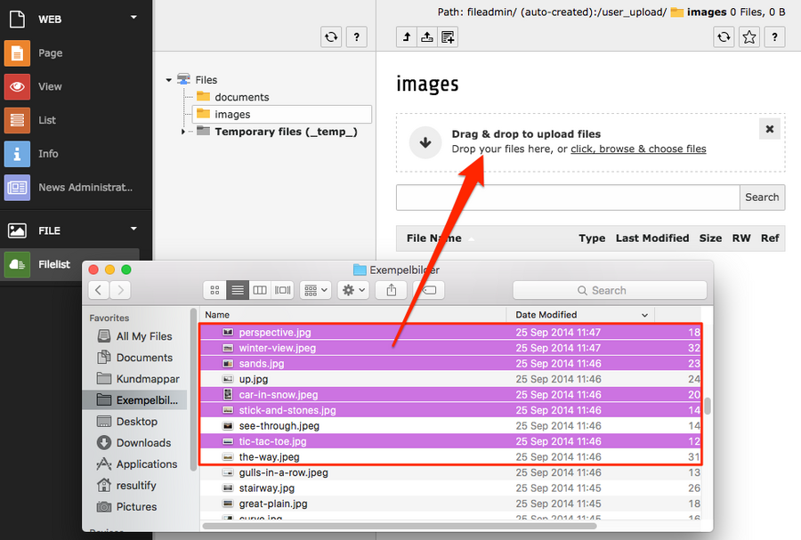3.3.1
If the files you are trying to upload, already exist in the folder, you will be asked to complete an action for these files. It can be done file by file (1) or as a mass action (2). After you have selected actions click "Continue with selected actions". (Img. 3.3.2)
Please note that this function is based on a file having the identical name and format, including the use of capital letters in both the name and the file format.
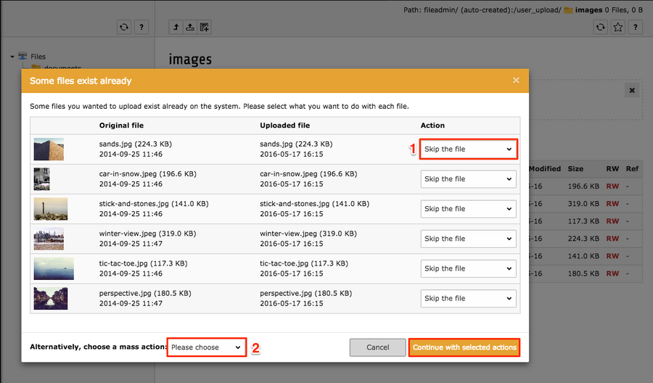3.3.2

3.4 Delete files
To delete a file, first make sure that the option "Extended view" is active, then click the trash can icon to delete the file. (Img. 3.4.1)
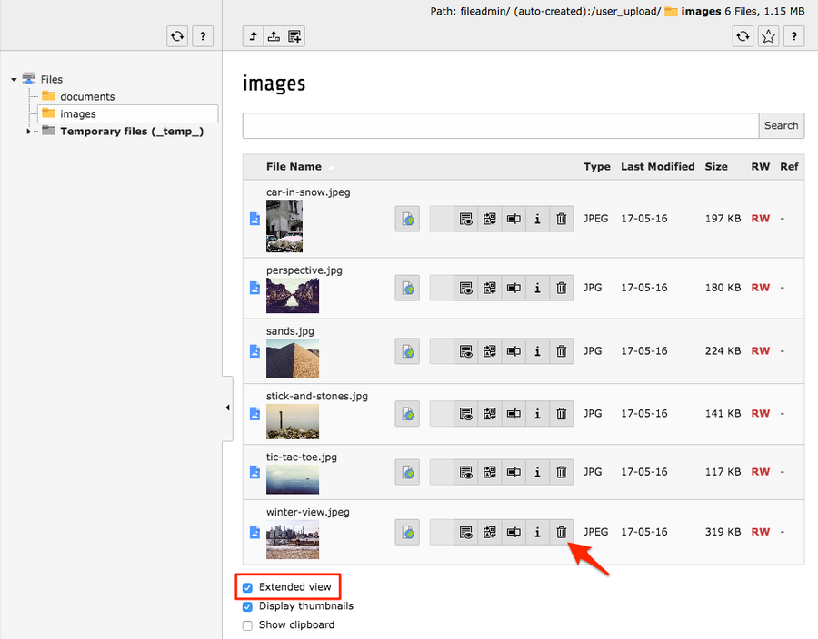3.4.1

3.5 File Metadata
To gain ranking of your website on the search engines you can use metadata to your files. To access the file metadata, click the title of the file when you are in the folder. (Img. 3.5.1)
All fields, except for keywords, can be edited when the file is used in a content element. But by adding it through the Filelist, it is automatically pushed out to where the file is being used.
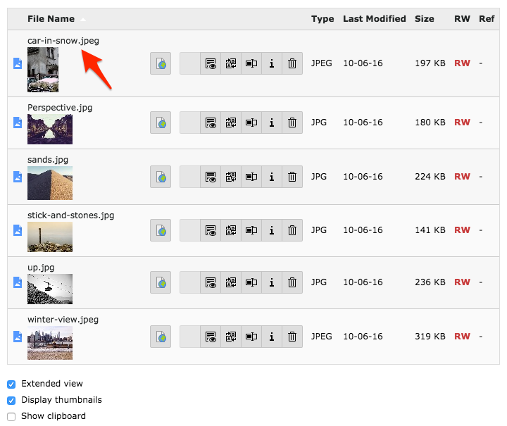3.5.1
The metadata contains 4 fields (Img. 3.5.2) :
(1) - "Title" shows up on the front end when the visitors mouse over the image. It can also be used in the element type "File Links" as the title of a downloadable file, instead of using the file name.
(2) - "Description" is connected to the caption for images. In the case of using a "File Links" element, the description text will appear below the link.
(3) - "Keywords" can be added to the file, comma separated, to enhance search results.
(4) - "Alternative text" is connected to accessibility of the file, meaning if the image cannot be displayed on the front end or is the visitor is visually impaired (having a program read the information for them), this text will be used instead of the image. But it is also a good way to add more information to the page, that the search engines can use. In regular cases, this text is only visible in the HTML code.
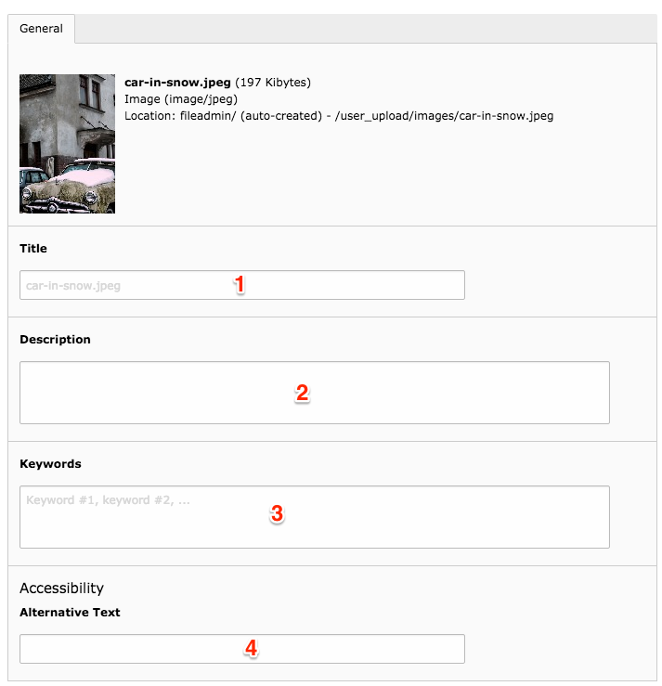3.5.2

3.6 Handle multiple files in Filelist
The clipboard allows you to move and delete several elements at the same time. To activate the clipboard function, make sure that you have the checkbox 'Show clipboard' checked. You can find the checkbox below the listing of files in Filelist. Afterwards a new section will appear below the checkboxes containing the clipboard. (3.6.1)
NOTE! This function can also be applied to the use of List view, and moving content elements.
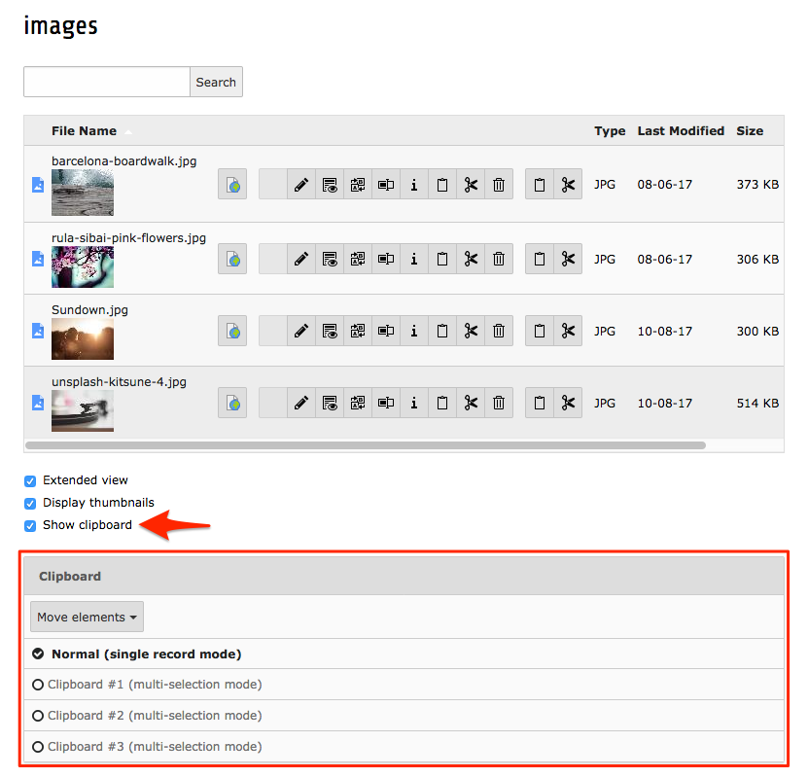3.6.1
To use the clipboard, select one of the three available clipboards by clicking on it. A column with checkboxes and icons appears on the right-hand side of the file management icons. (3.6.2)
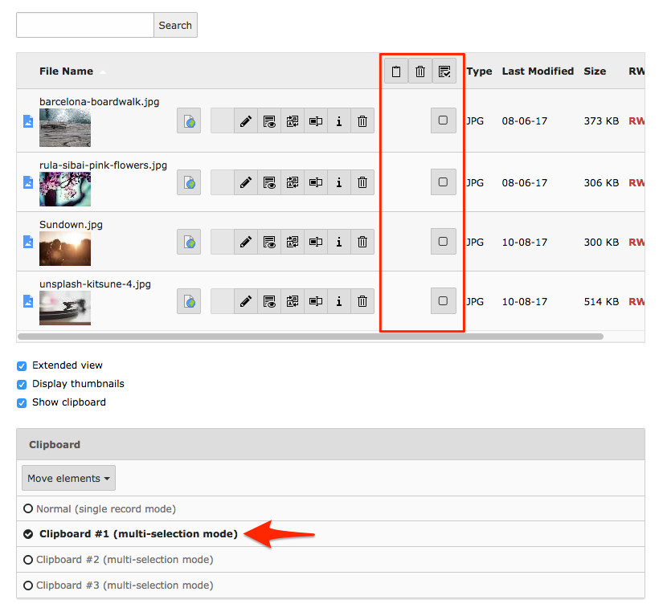3.6.2
Select objects with the checkboxes and then an action with the icons above. You can move selected items with 'Transfer the selection of files to clipboard' (1). If you click the trash can icon (2) to delete content you will be asked to confirm if you wish to remove these objects. Finally there is an icon to select/un-select (3) all items in the list. (3.6.3)
The three available clipboards make it possible to collect files from one folder, into the separate clipboards, to later paste the content into separate folders.
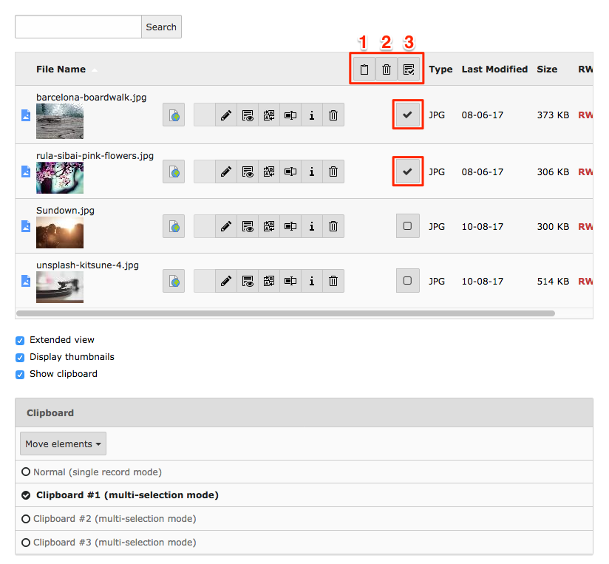3.6.3
After transferring selected files to a clipboard, you will be able to see them in the section below, and it is also possible to see information about each file (the i-icon) and also remove them from the clipboard through the trash can icon. (3.6.4)
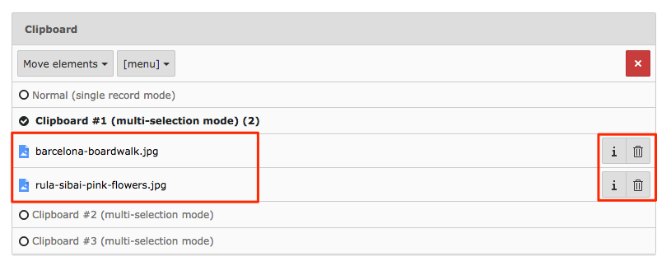3.6.4
By clicking another folder in the filelist, you are there able to paste the content from a clipboard. Use the 'Paste in clipboard content' icon, marked in the image, to paste the content. (3.6.5)
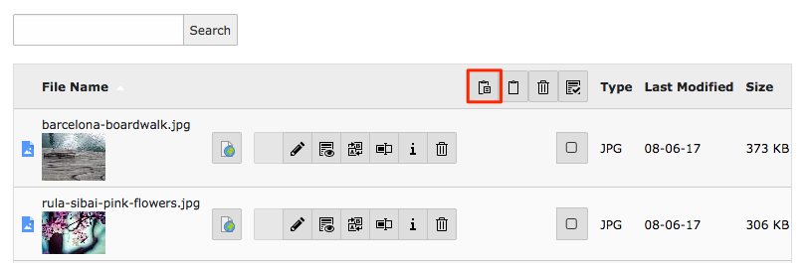3.6.5

4. Content handling
In this section you will learn how to create content elements on your website, edit, move and delete them.

4.1 Creating content elements
The content of a page is created by using different types of content elements. You can build the page by using a variation of elements in combination with each other.
Select the page you wish to add content to in the page tree, by clicking the title of it. Now click the button 'Content', inside the content area, to add a new element. (4.1.1)
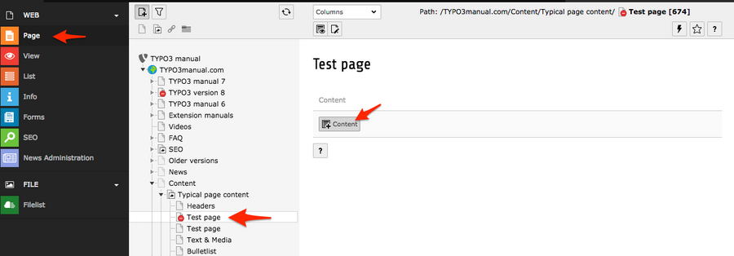4.1.1
A number of tabs, with different types of content elements, appears. You can read more about the different element types here.
For this section we will use the "Text & images" element, so let's select it below the tab "Typical page content". (4.1.2)
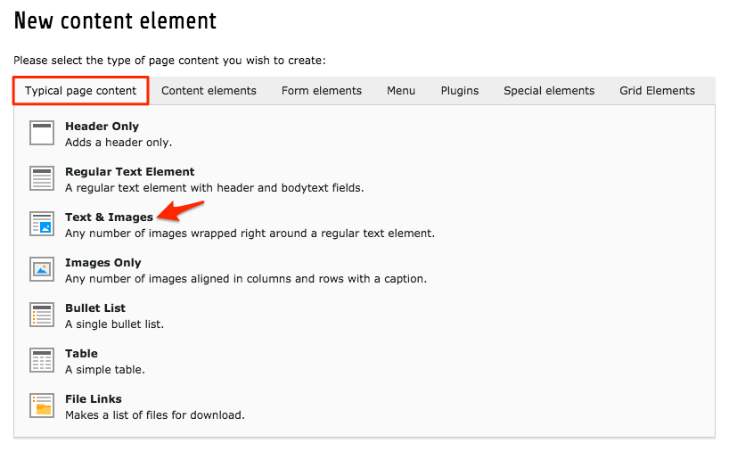4.1.2
'Text & Images' is probably the element that is used the most on a website.
The 'General' tab contains information about the type of element (1), shows which content field it is placed in and also allows you to move the element between the available content sections (2). Here you can add the header (3), set what type of layout the header should have (4) and set the alignment of the header (5). There is an option to link the header (6), but note that this will change the design of the header. The 'Subheader' field (7) can be used to add a smaller header below the main header. Finally we have the body text field (8). (4.1.3)
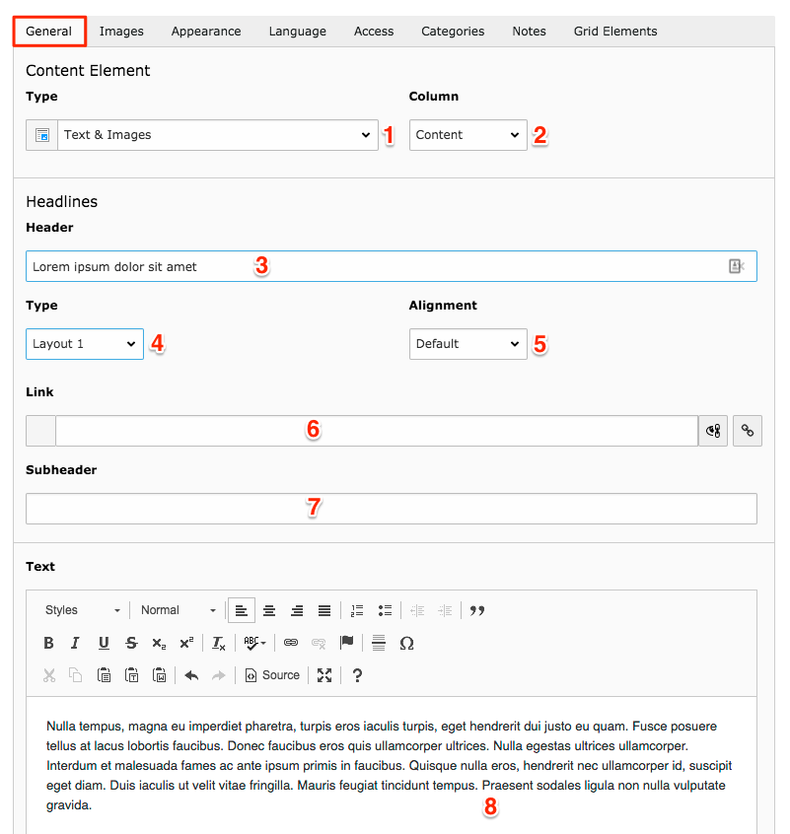4.1.3

More information about some of the fields:

Content type
The content type dropdown shows what type of element it is, and also allows you to switch between different types of elements. If the fields you have filled out, has an equivalent field in the element type you switch to, the applied text/settings will be transfered.
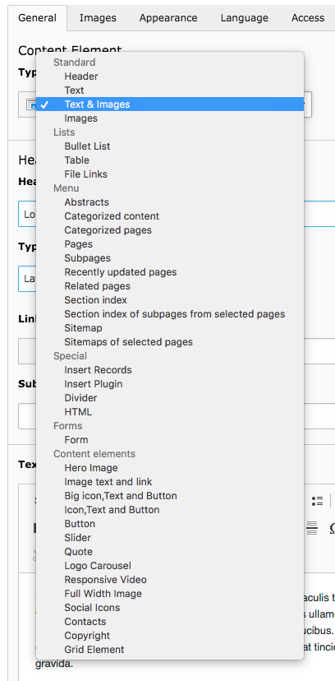

Content column
In the case a page template contains more than one content field, it is possible to move the content element between these content fields using the drop down.
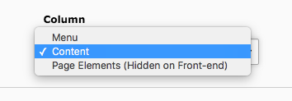

Header Type
The header layout types control the design of the header in the frontend, but also communicates to the search engines, the importance of that header.
The first header of a page, should always be set as Layout 1. It is the largest of the headers, but it also has the function of the H1 tag. The H1 tag indicates to the search engines that it is the most important header on the page. Read more about optimizing your website.
Layout 2 - Layout 5 also has different styling on the frontend (where layout 2 is the largest and layout 5 the smallest), and also indicates to the search engines the importance of the content. Layout 2 should be used as sub headers, and if needed, the rest can be used as sub header for layout 2.
You can hide the header from the frontend, by using 'Hidden' option, but still be able to use it as a an internal name for the element.
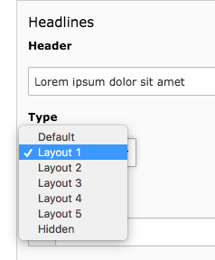

Text area
The text area can be compared with a down-scaled Word document. It allows you to add headers in the text, apply bold and italic, create links etc.
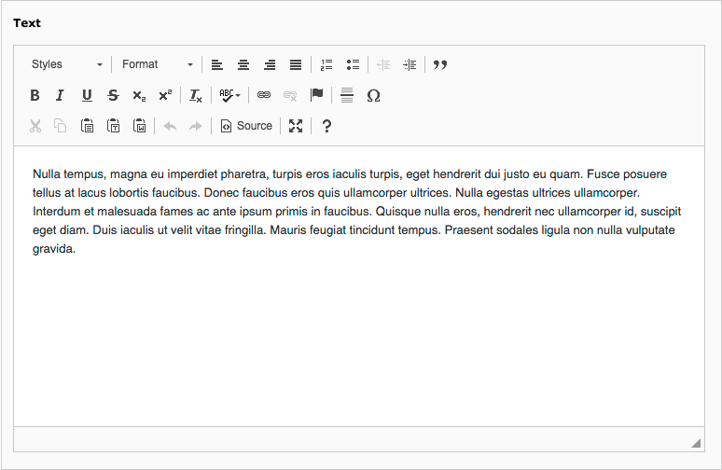
In 'Images' tab you can add an image via the Filelist, for this you need to click "Add image" button. The accepted file formats are listed below the button. (4.1.4)
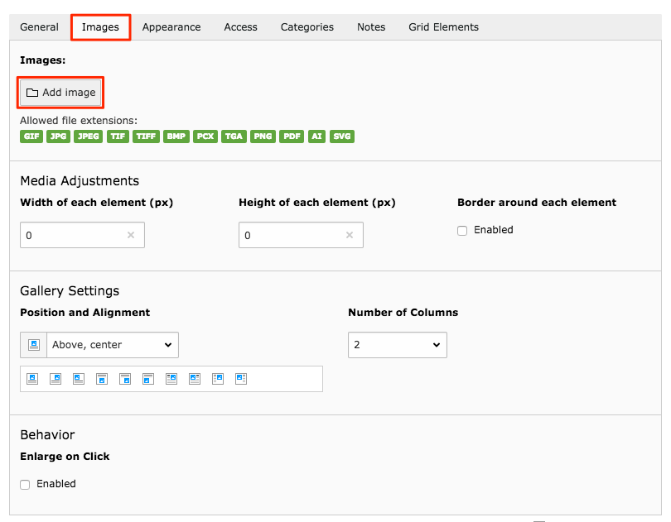4.1.4
After selecting "Add image", choose folder (1), and click the file name (2) or the image (if you have enabled to 'Display thumbnails'). (4.1.5)
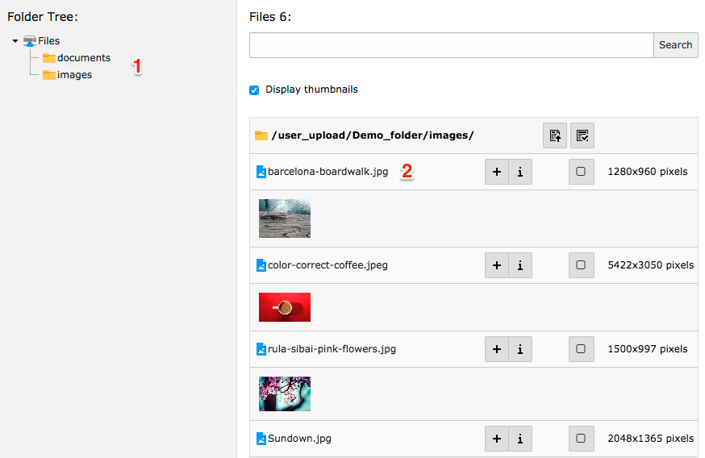4.1.5
If you wish to upload a file, select the folder in which you wish to upload the file/files in and click 'Choose files' (1) in the bottom section of the 'Filelist' popup. (4.1.6)
Select files from your local computer and click Open. In field (2) you can see the accepted file formats and you can also overwrite the existing files (3). Then choose "Upload files" (4), and the files will be uploaded to the folder.
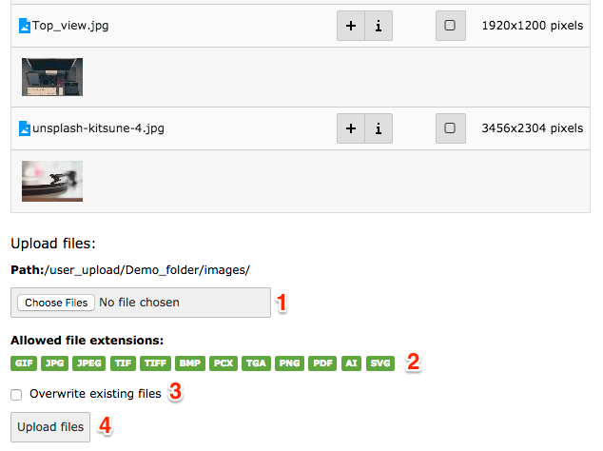4.1.6
The file information is added as a section in the element. If you filled out the Metadata in Filelist, this will be shown in the fields Title (1), Alternative text (2) and Description (4). It is possible to link the file: paste a link address or use the link icon on the right hand side of the field (3). You can aslo delete (6), hide (7) or move (8) the image. The image can be cropped by using the 'Image manipulation' (5). ( 4.1.7)
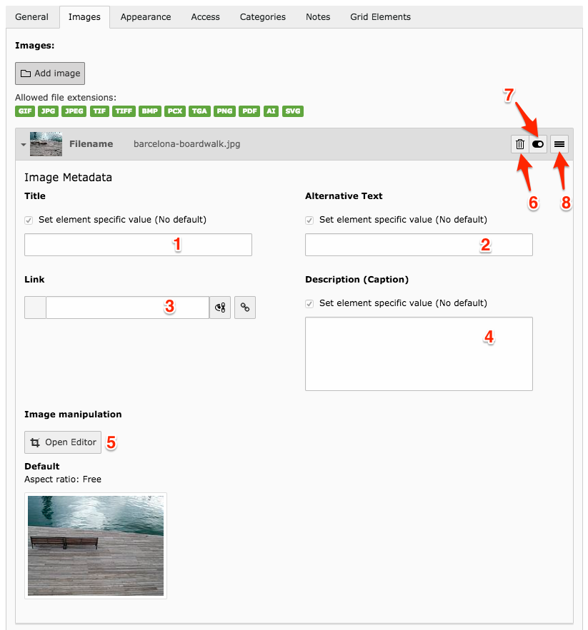4.1.7
To edit the image, click "Open Editor" to enter the editor (5). (previous image, 4.1.7)
Select a fixed ratio (16:9, 3:2, 4:3, 1:1) or crop freely (1). (4.1.8)
After you have selected the area you wish to crop, you will see the 'Selected Size' in px (2) and if you want to come back to the initial parameters use 'Reset' button (3).
Then click "Accept" (4) and the cropped area will now be shown as a thumbnail in the image information (see previous image, 4.1.7).
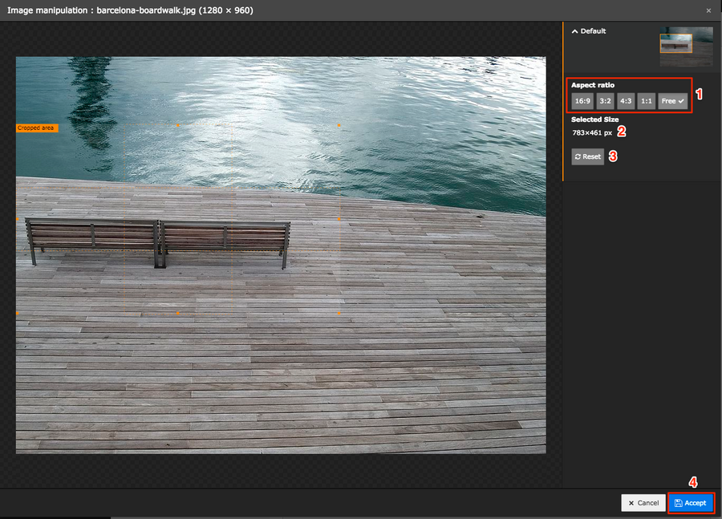4.1.8
You can also do 'Media Adjustments' of images (1), like: resizing it by adding 'Width' (2) or 'Height' (3) and adding a border (4).
Positioning and aligning the file to the text (5) is also possible. If you have added more than one file, you can select how the files should be placed in alignment to each other, by using columns (6).
At the bottom, there is an option to enable "Enlarge on Click" (7), to have the image open in a lightbox.
(4.1.9)
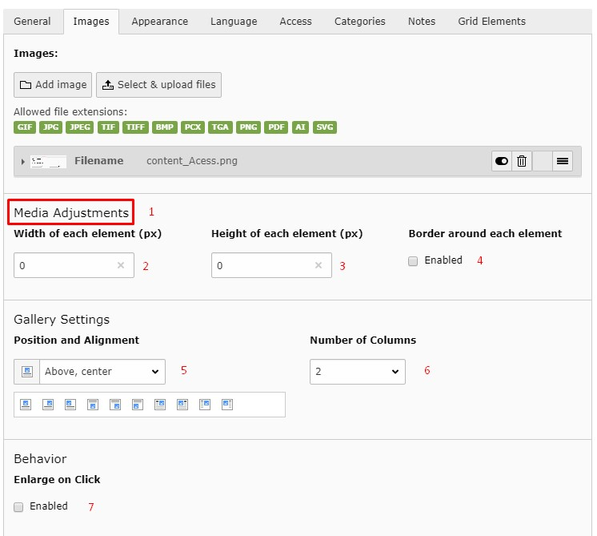4.1.9
The 'Appearance' tab has options for the layout and style of the element. The options can vary depending on the type of content element. (4.1.10)
Some types of content elements can have different layouts (1) applied to them. For example, a list of downloadable files can have an icon to show what type of file it is, or a thumbnail of the image or first page of a PDF.
The appearance option (2) allows you to add background colours, or inverse the colour scheme of the element text. This is a function depends on the design of the website.
Sometimes it is necessary to create more space between elements or to add some margins - this can be added before the element (3) or after it (4).
It is also possible to set an alignment for all the text in the element (5), for example to have it centered. Using the 'Special menus' element allows you to create a listing of elements using the element headers. To exclude a header of an element, uncheck the 'Show in Section Menus' checkbox (6). Finally you can add a link to top of page (7), which will add a 'To top' link at the bottom of the content element on the frontend. By clicking this link, the visitor will be sent to the top of the page automatically.
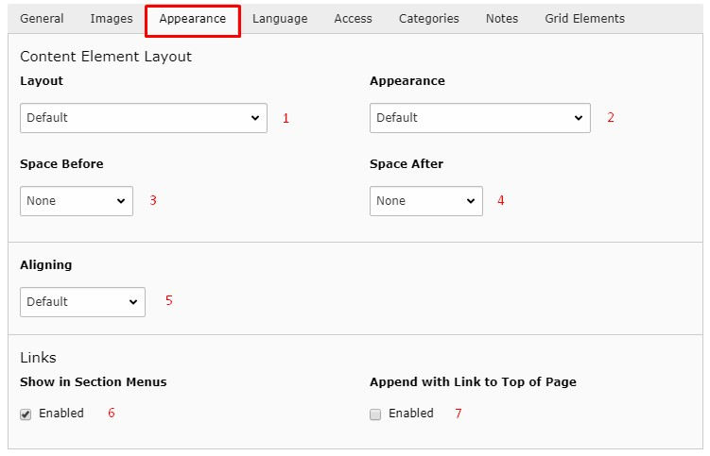4.1.10
The 'Language' tab shows to what language the element belongs to, if the website is using 'Language layers' to have different languages on the frontend. (4.1.11)
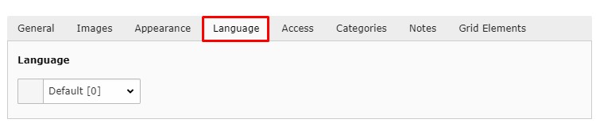4.1.11
The 'Access' tab able you to publish/un-publish the content, by disabling it (1).
You can also select a publishing (2) and/or expiration (3) date for the element. This is excellent for example when handling campaigns, product launches etc., when you need to publish a content without having to do it manually. It is not possible to preview content that has been set to publish at a later date, so make sure to do this as a last step. Also make sure that the disable checkbox is unchecked, otherwise the content will continue to be hidden. (4.1.12)
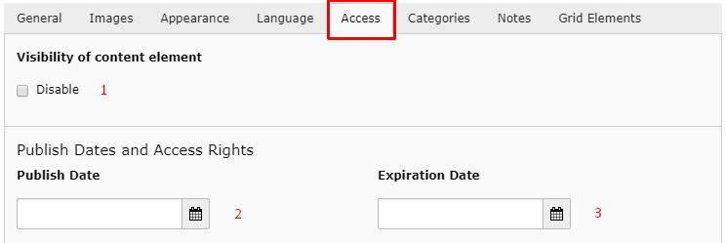4.1.12
In the 'Categories' tab you can set the connection of element to a category. This function can be used in 'Special menus' elements, where you can set it to show headers in a linked list, using all content elements connected to a specific category without regards to which page these elements are placed on. (4.1.13)
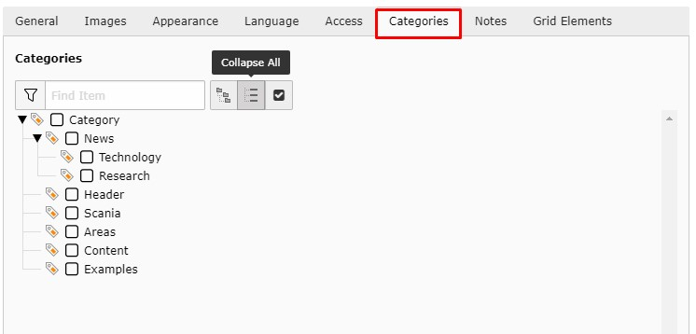4.1.13
In the 'Notes' tab you can add some notes to the element (4.1.14) - it will be not visible in frontend, but you can see it in backend (4.1.15)
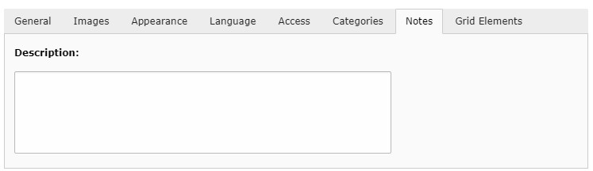4.1.14
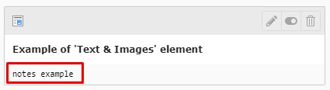4.1.15
In the 'Grid Elements' tab you can see the relation of the element to grid elements. It is also possible to move an element between grid columns using the dropdown menu. (4.1.16)
Read more about 'Grid elements' here >>
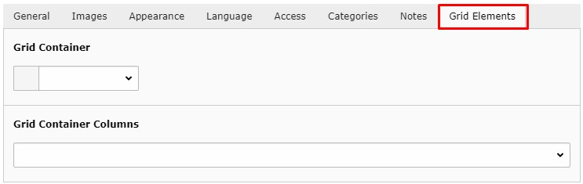4.1.16
After you are done filling out all the information, don't forget to save. The save function is placed at the top of the content element, with the option to 'Save'. It is also possible to use the arrow next to 'Save' for more options like 'Save and view page', 'Save and Create a new one' and 'Save and close'. (4.1.17)
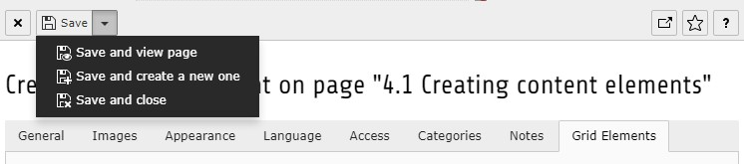4.1.17

