News Module TYPO3 version 7+
Here we go through the steps how to create news articles on your website. It is very important to keep in mind, that the news module contains different parts. First there is the page or pages on the website that contains the so called plugin, which collects information from the News-folder in at the bottom of the TYPO3 page tree. The news articles are always created in that folder. The pages containing the plugins should never be altered, because it could make the flow cease to function.

1. News listing

1.1 Enter the news folder
The news are normally stored in a folder in the page tree and you can access it by clicking List in the left hand menu and selecting the News-folder. The name of the folder may vary on different sites (img. 1.1.1).
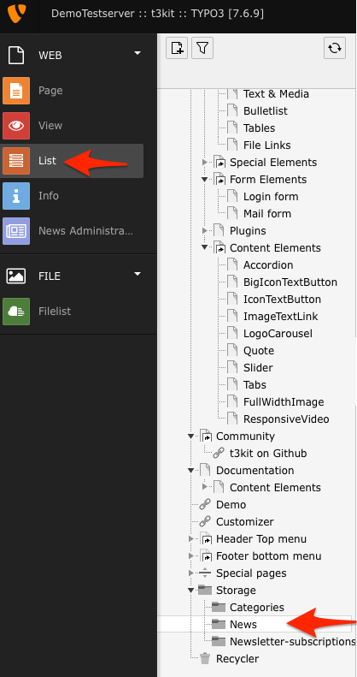1.1.1

1.2 Extended view
To access icons for editing the news, make sure that the 'Extended view' check box is applied (img. 1.2.1).
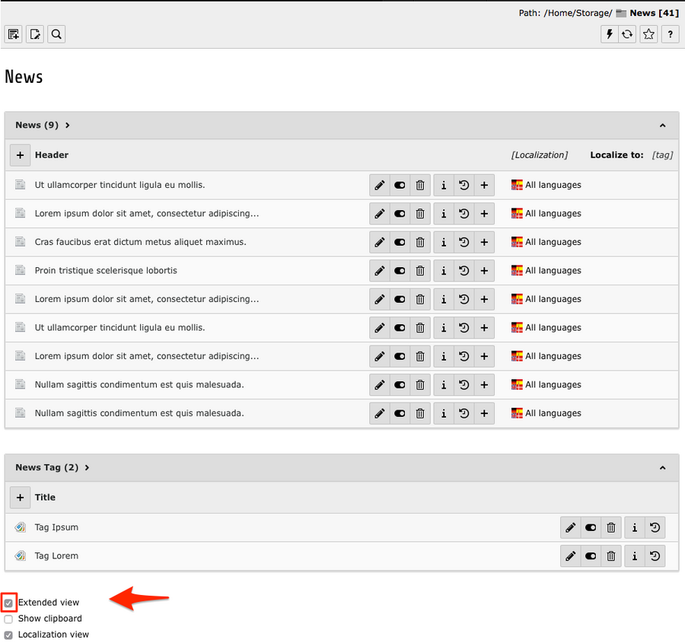1.2.1

1.3 Create and edit news
Create new articles by clicking the New record icon, the plus icon at the top of the news listing. Current news can be edited by clicking on the pen icon to the right (img. 1.3.1).
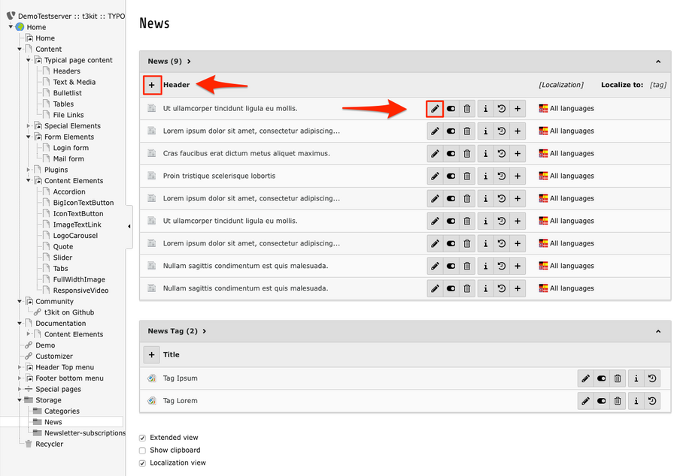1.3.1

2. Create new news article

2.1 Adding text to your news
A news record has five tabs with information. The first tab, 'General', contains the general information of the news.
The 'Header' field is shown in all views as the news header (1).
It is possible to create three different types of news which can be selected from the drop-down (2).
The first, 'News', is a regular news article with header, teaser and text. The second option, 'Link internal Page', has the header and teaser, but not text. Instead you can link it to an internal page. The last option, 'Link external page', also has the header and teaser and then a link option to add an external website.
A news article is not hidden when created, so make sure to check the hide box, if you do not wish to publish the news article directly (3).
Usage of the 'Teaser' field (4), is varied on the different TYPO3 websites. Some news modules doesn't use it at all and some only in the listing views. If used in the single news view it is often displayed in a bolder font above the body text.
'Author name' (5) and 'Author mail' (6) fields can be used to show who wrote the news. These fields are optional, and leaving them blank will not affect the frontend.
The 'Date & Time' (7) field is the date that is shown next to the news article, but also what structures the listing order on the frontend, so that the latest news is listed at the top. When created, the news is given the creation date, but it is possible to adjust the date.
Using the 'Rich Text Editor' (8) works the same way as in the text elements. (img. 2.1.1)
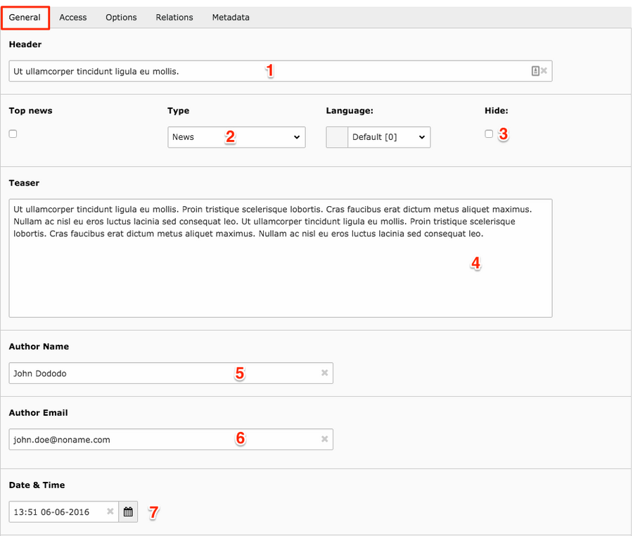
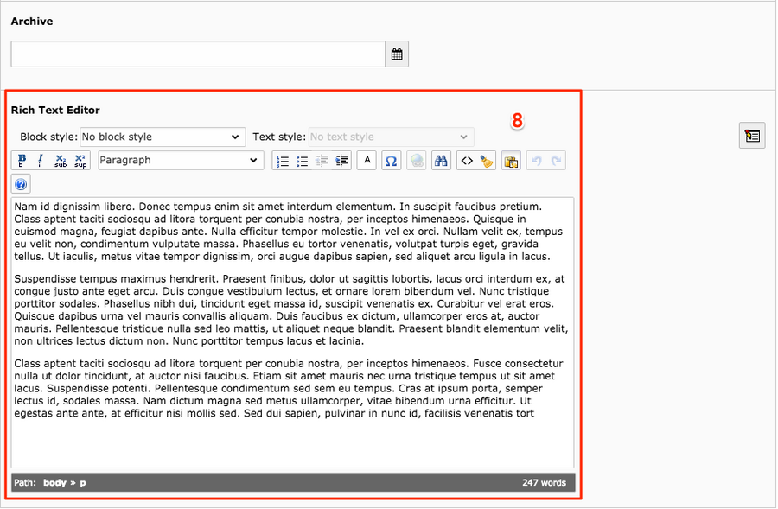2.1.1

2.2 Setting date
The tab 'General' also contains information regarding the news date. It is this date that organizes the order of the news articles in the listing. (img. 2.2.1)
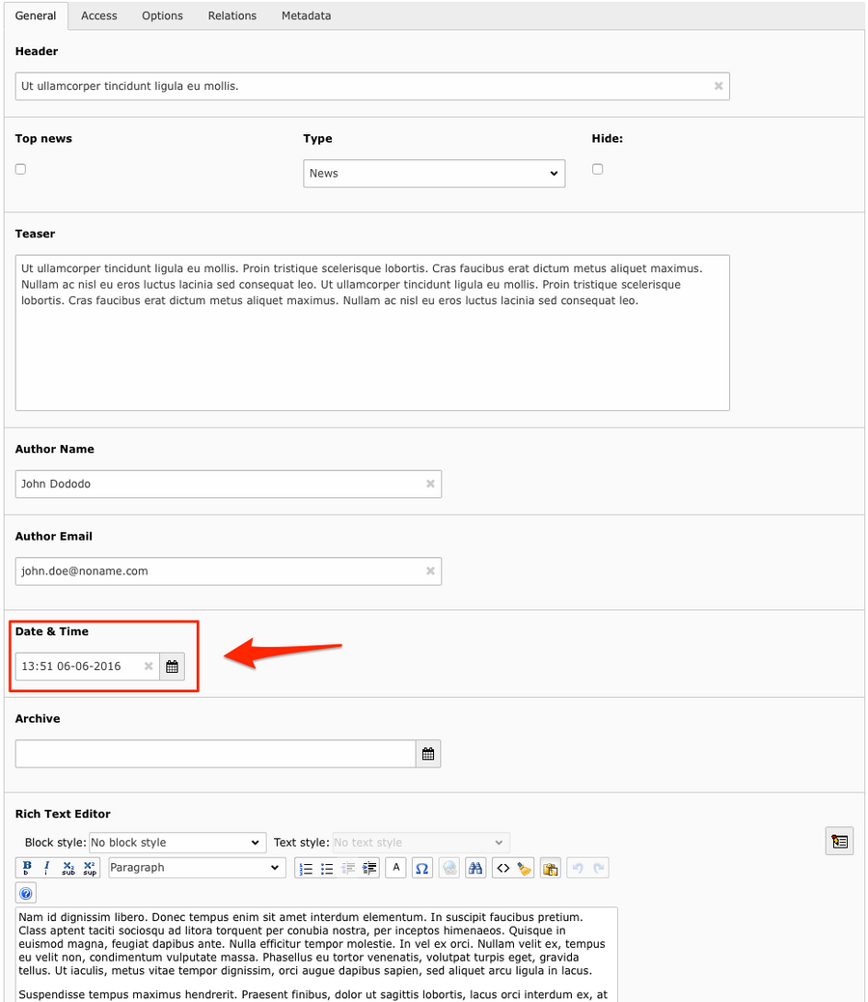2.2.1

2.3 Access and publishing dates
The 'Access' tab allows you to set start and end date for the visibility of the news. Always remember to adjust the date under the 'General' tab as well, if you set a start date, so that the article has the correct date when published. (img 2.3.1).
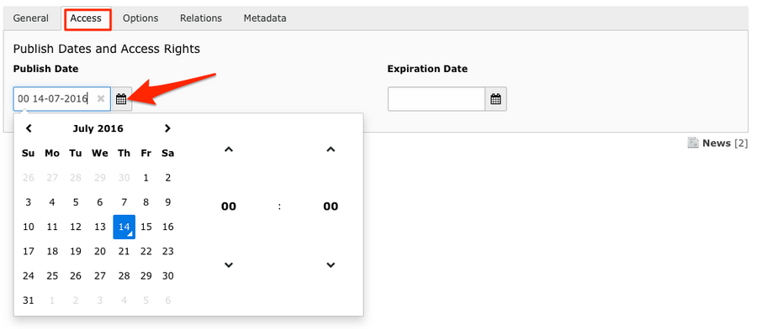2.3.1

2.4 Categories
Some websites use a function to categorize the news. This means that the news can be displayed in different places on the website, for instance separating news into regular news and press releases. Below the tab 'Options' you can add categories by checking the box of the category (1). (img 2.4.1)
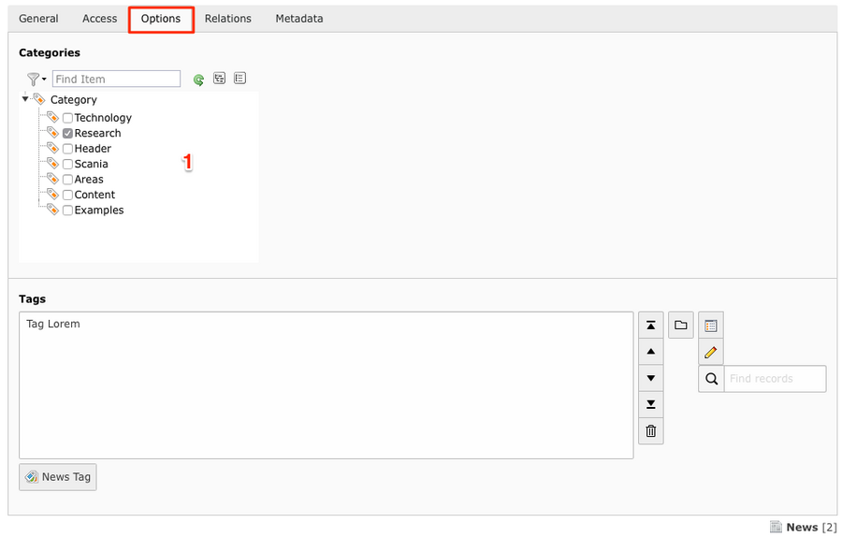2.4.1

2.5 Adding image or movie to the news article
To add an image or video to the news, go to the tab 'Relations'. Click 'Add media file', to open a window with the 'Filelist' and select the file from there. (img. 2.5.1)
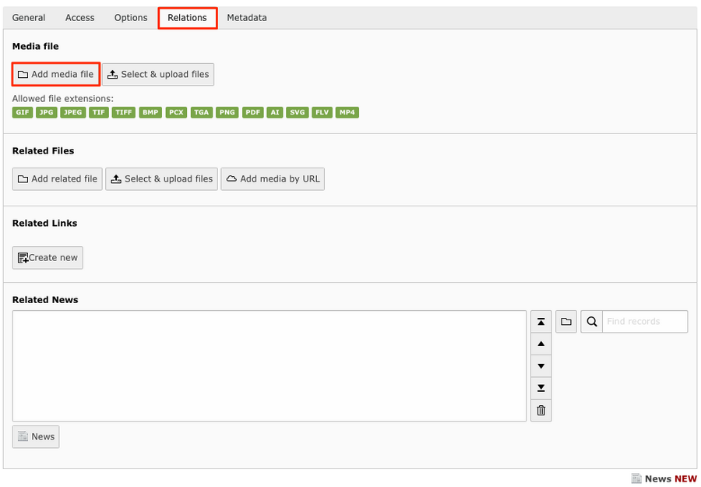2.5.1
If you wish to have a thumbnail shown in all list views, check the box 'Show in preview views' (1). You can add a caption to the media file selected. To write a caption you check the box 'Override' (2) and write below your caption. The title text can be displayed, when holding the cursor over the media file. (img. 2.5.2)
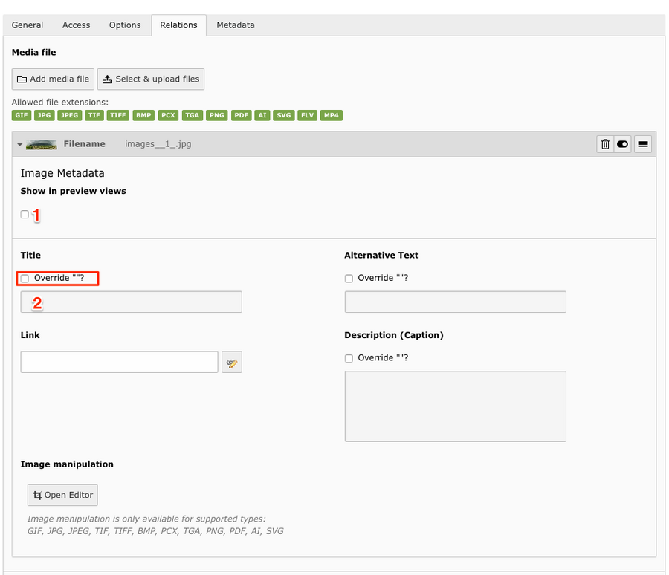2.5.2

2.6 Add files to news article
You can add files that will be downloadable below the news article. Go to the 'Relations' tab and below the section 'Related files' click 'Add related file'. Select the file from 'Filelist' in the popup window. (img. 2.6.1)
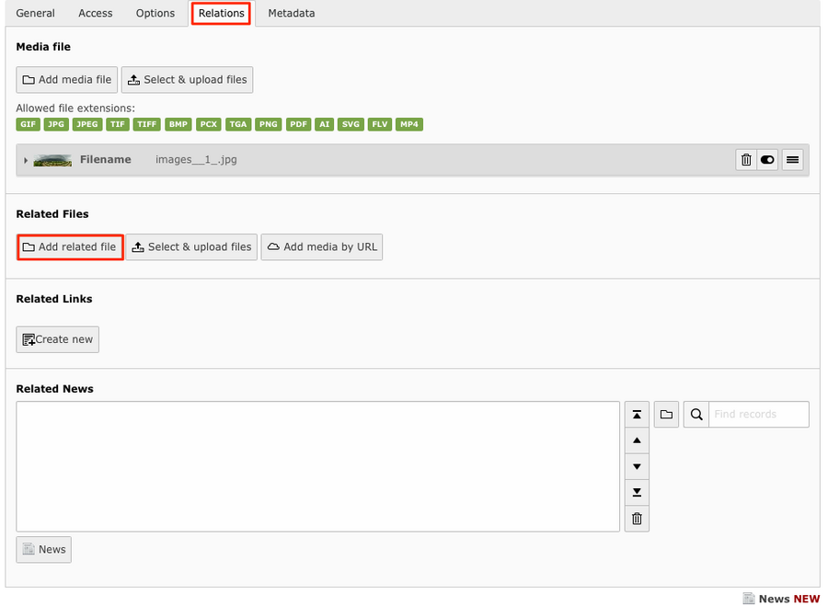2.6.1
Add a 'Title' for the file (1), which will show as the link text and finally a short 'Description (Caption)' of the file (2). The latter is optional. (img. 2.6.2)
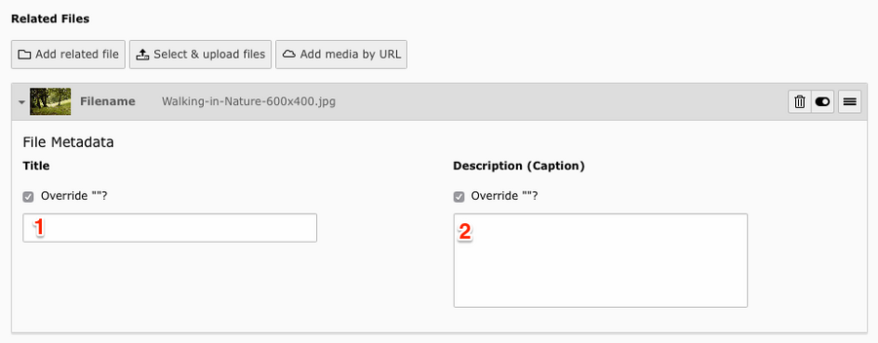2.6.2

2.7 Add links to news article
You can add links that will appear below the news article. Go to the 'Relations' tab and below the section 'Related links' click 'Create new'. (img. 2.7.1)
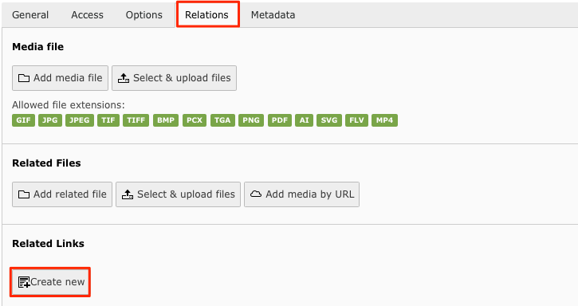2.7.1
Add link address to the field, fill out a 'Title' that will be the link text on the front and if you want a short 'Description' of the link. (img. 2.7.2)
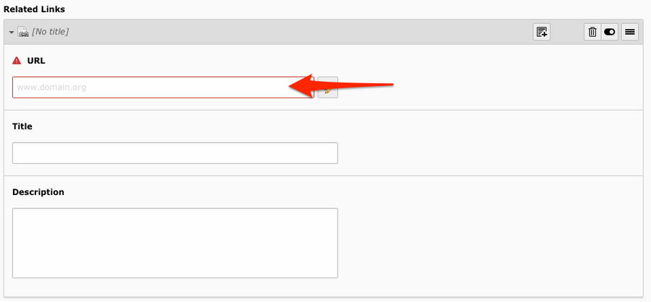2.7.2

2.8 Add related news to news article
You can add related news that will appear below the news article. Go to the 'Relations' tab and search for news items in the search field, marked 'Find records', by typing the title of the news. They will appear as options, select by clicking the title of the news. It will then be added in the field to the left. If you don't know the title, it is also possible to click the folder icon next to the search field or the 'News' button below. This will open up the page tree in a popup. Go to the News-folder in the tree and select your news article in the list. (img. 2.8.1)
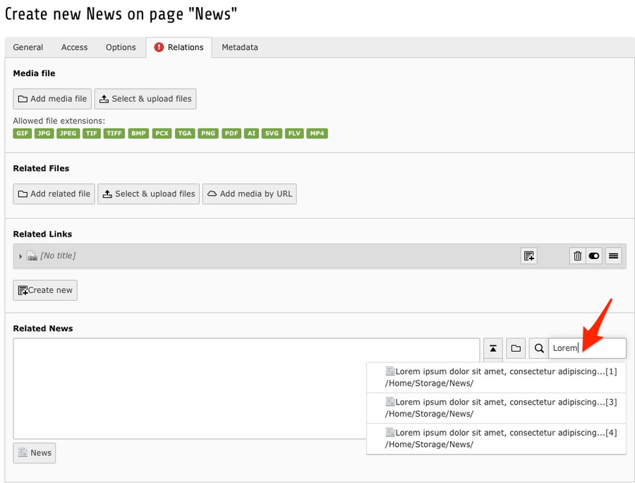2.8.1

2.9 Add news tag
News tags can be used as a filtering option, in addition to categories, for news articles.
To create a new tag, select 'List' in the left hand menu and go to the news archive folder. In the folder you have a section called 'News tag'. Click plus-icon next to 'Title' to add a new tag. (Img. 2.9.1)
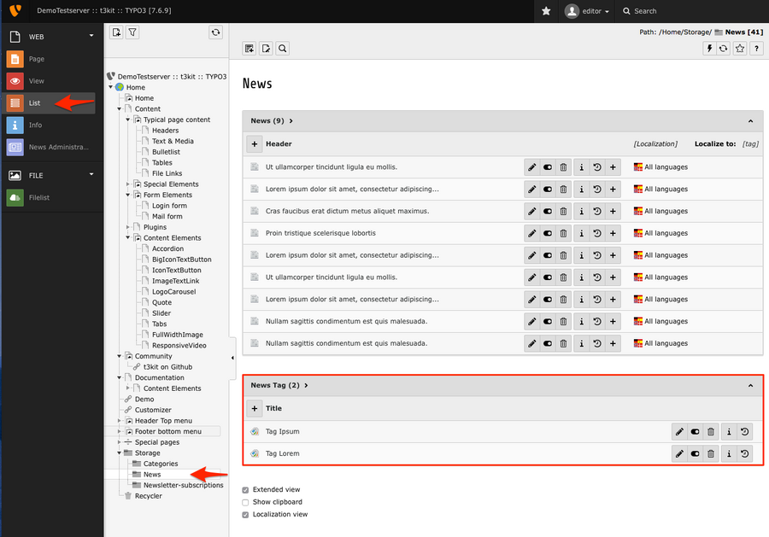2.9.1
Write the tag title in the field and save an close. (Img. 2.9.2)
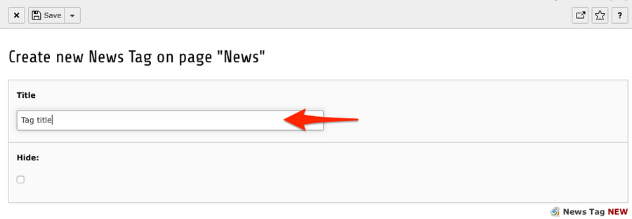2.9.2
To add the tag to a news article, go to the 'Options' tab inside the article. At the bottom you will find a section for adding tags. You can either search for it by typing the title of the tag in the search field, or by clicking the folder icon, and fetching it from the news folder in the popup window. (Img. 2.9.3)
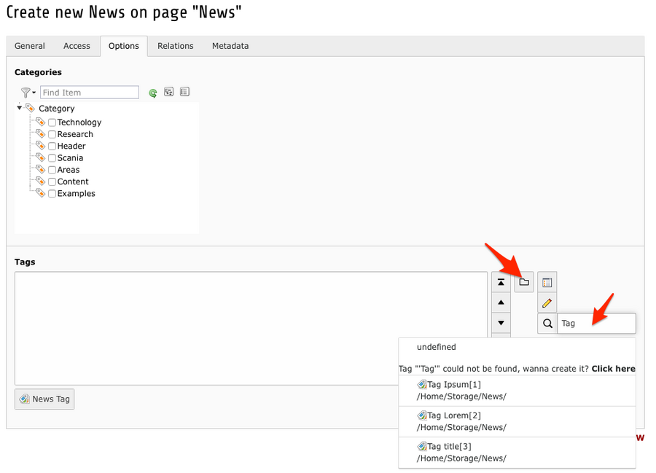2.9.3

2.10 Add keywords
To add keywords and description for the news article go to the tab 'metadata'. There you can write the 'Keywords' (1) comma separated, and add a 'Description' (2). It is also possible to alter the address (web address) for the news article by adding it to 'Speaking URL path segment' (3). (img. 2.10.1)
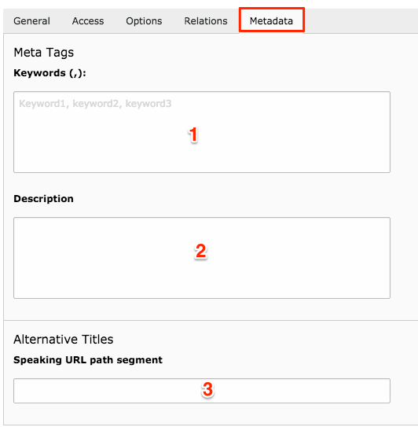2.10.1

2.11 How to create categories
News categories can be used as a filtering option for news articles. This means that the news can be displayed in different places on the website, for instance separating news into regular news and press releases.
To create a new category, select 'List' in the left hand menu (1) and go to the Categories archive folder (2). Click plus-icon next to 'Title' (3) to add a new Category. (Img. 2.11.1)
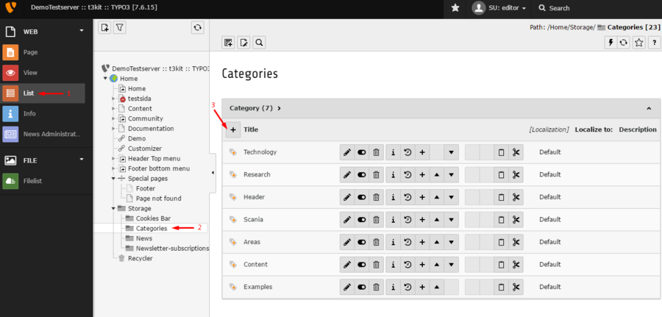2.11.1
Write the Category title in the field (4), 'save and close' it (5). (Img. 2.11.2)
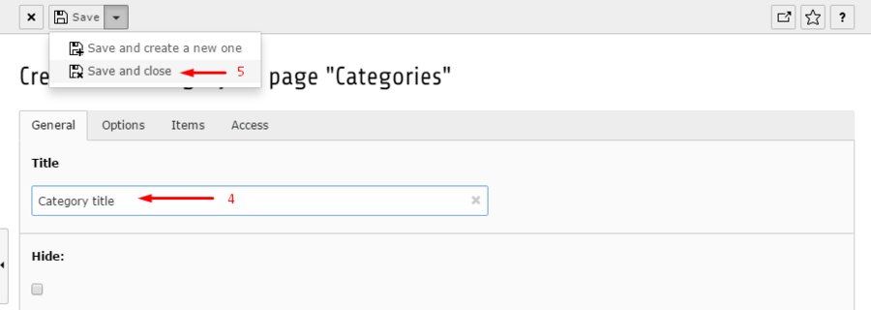2.11.2
To add the created Category to a news article go to the News archive folder (6), then go to the 'Options' tab inside the necessary article (7). Below the tab 'Options' you can add categories by checking the box of the category, there you have an opportunity even to add several categories to one news article (8). (Img. 2.11.3)
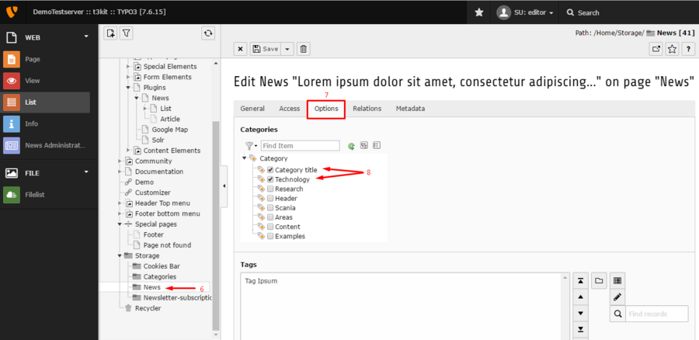2.11.3
If you want to check what news articles belong to each Category, you can use 'Item' tab inside the necessary Category (9) and there you can see the list of all news relevant to that Category.
There you may delete, move them up and down (10) or add other news articles by using folder icon in right corner (11). (Img. 2.11.4)
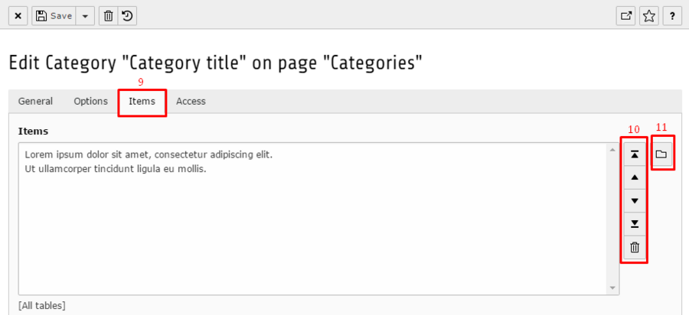2.11.4
When you click right corner icon (11), you will see the whole page tree of the site, there you just need to choose News archive folder and then you will see the list of all news and choose which articles you would like to connect to the category. (Img. 2.11.5)
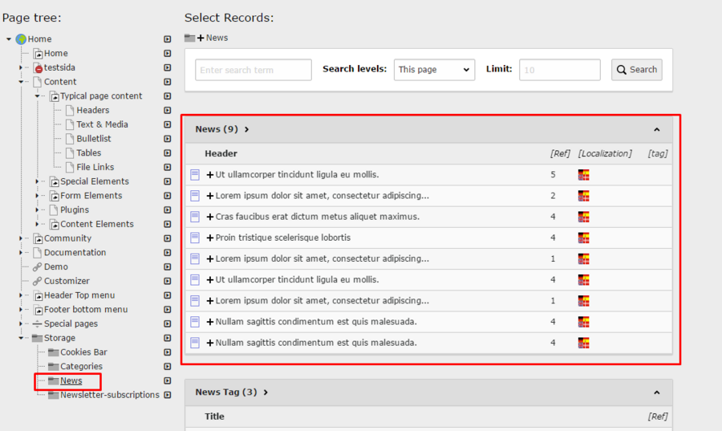2.11.5

2.12 News article types
There are three differens types of news articles; The default news article type is where you add all text directly in the news record, the second type allows you to link to an internal page (or to a file) on the website and with the third you can link to an external page (Img 2.12.1).
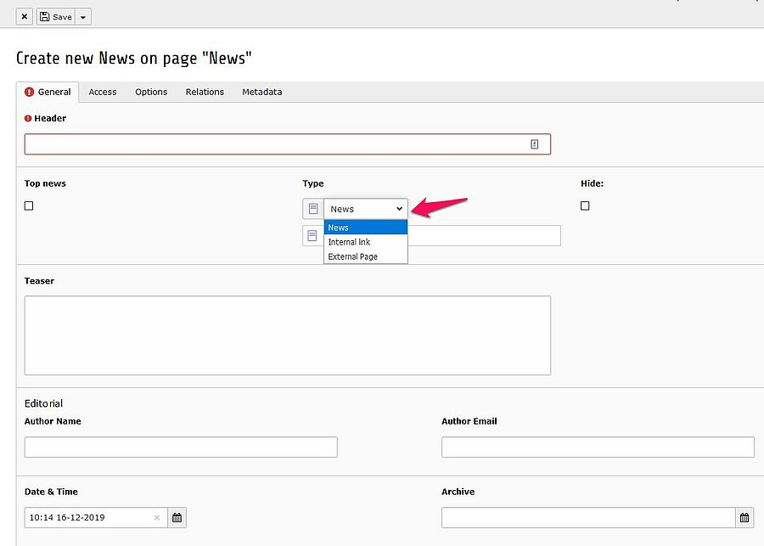Img 2.12.1

Default news article
When you create a new news article, the default is automatically selected. You can read more about this type in chapter 2.

Link news article to internal page
After adding a new news article, and hiding the record, you can switch news type to 'Internal link'. Click 'OK' to accept the switch.
For this news type, you will add a header, teaser, date and image. But instead of the text field you will instead have a link field to create an 'Internal link' (Img 2.12.2).
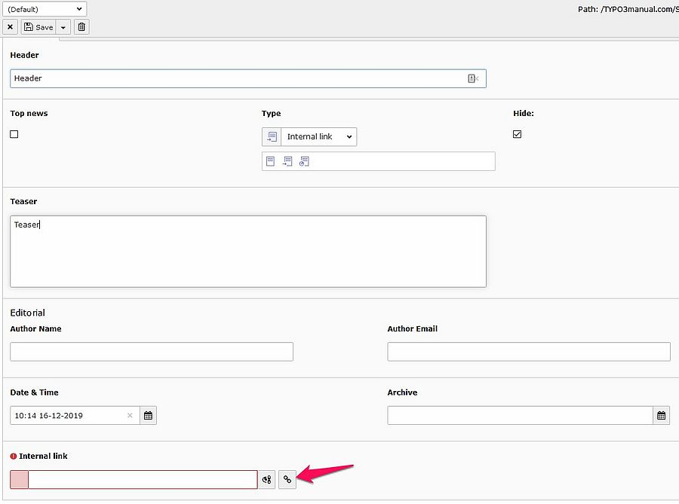Img. 2.12.2

Link news article to External page
The third news article type gives you the posibility to link to a page outside og the website. Click 'OK' to accept the switch.
For this news type, you will add a header, teaser, date and image. But instead of the text field you will instead have a link field to create an 'External link' (Img 2.12.3).
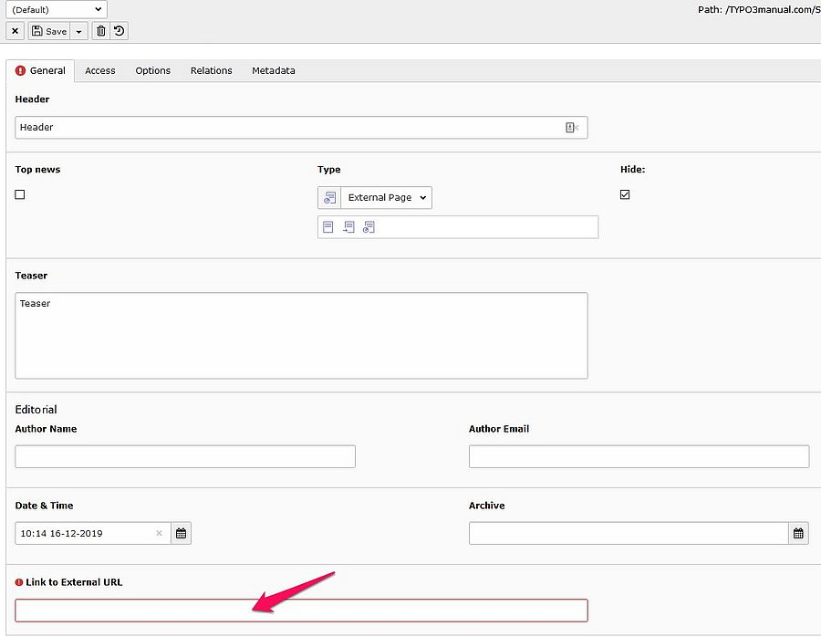Img. 2.12.3

3. Plugin settings (general)
This section will show you how to add and configure the news plugin on a page, to be able to show the news articles.
The plugin can be set to show all news from a folder, or selected articles using categorizing.

3.1 Setting up page structure
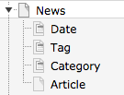
The news function is dependent on a certain set of pages.
1. There needs to be a main page, listing all news (or certain categorized news).
2. A page for showing the detailed news article also needs to be present. One page can be used for all news plugins, or you can create designated detail views.
3. If you are using the archive menu, there needs to be a separate page to show news from specific month. The page can use the content from the listing page (Image 2.2.7, numbers 3-5).
4. If you are using the category menu, there needs to be a separate page to show news from specific category. The page can use the content from the listing page (Image 2.2.7, numbers 3-5).
5. If you are using the tag function, there needs to be a separate page to show news from a specific news tag. The page can use the content from the listing page (Image 2.2.7, numbers 3-5).
Pages 2-5 should be set to 'In menus: Hide'.
The image on the upper right-hand side shows a recommended structure for these pages.

3.2 Setting up the news plugin
The list view setting in the plugin will list news from the news folder. It can show all news, without restriction, or be configured to show news from specific category or to push Top news.
Create a new content element on the page, and select 'News system' below the tab 'Plugins'. (3.2.1)
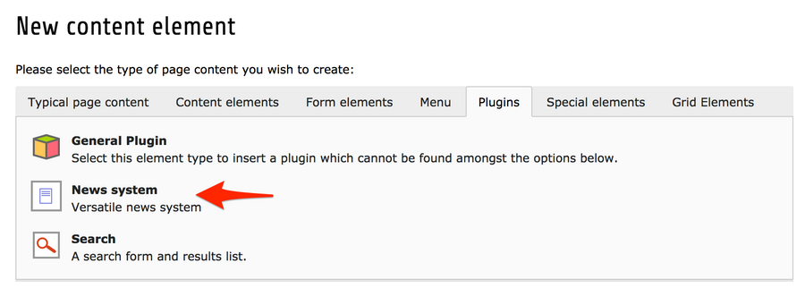3.2.1
After opening the plugin element, go to the tab 'Plugin' and the first tab below, 'Settings'. Start by selecting what the plugin should show (img. 3.2.2):
- List view; Used to list all news articles, or can be set to show articles from a specific category or push Top news.
- List of selected items; Select news articles to show in a list.
- Detail view; Used to show the individual news article.
- Date menu; An archive function that automatically adds new articles in a date menu.
- Search form; Specific search field used for news articles.
- Search result; This plugin can be placed on a separate page to show news search results.
- Category menu; Lists available categories for filtering news articles.
- Tag list; Lists available subject tags for filtering news articles.
Depending on what setting is selected, the fields will change. If a prompt window is shown, click 'OK'.
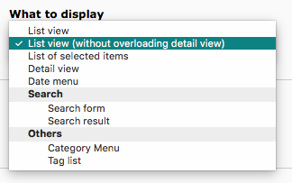3.2.2

3.3 Configuring the list view
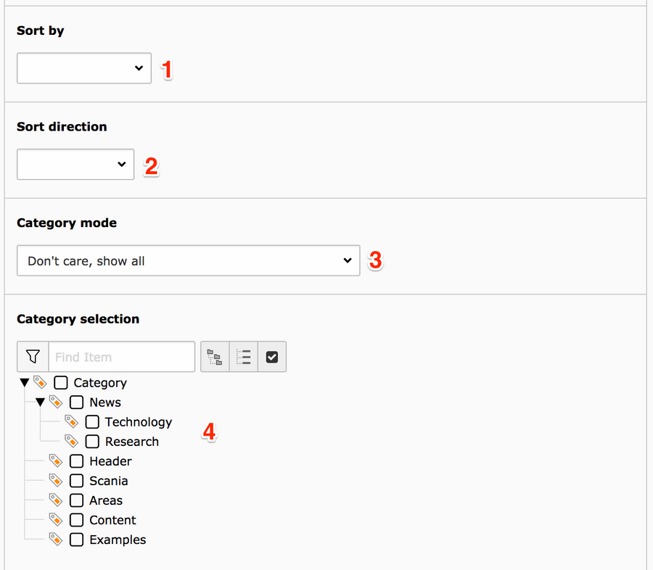3.3.1
Please read the section about page structure, before continuing.
After selecting 'List' ('Plugin' --> 'Settings' tab), continue down to dropdown with 'Sort by' (1) and set to either; 'Last edited', 'Given date/time', 'Created' or 'Title'. After that you can decide if the 'Sort direction' (2) should be 'Ascending' or 'Descending'.
You can specify if only news from one or more categories should be displayed. The 'Category mode' (3) can be set to;
- Don't care, show all; No restriction
- Show items with selected categories (OR); Will show all news articles belonging to at least one of the selected categories.
- Show items with selected categories (AND); Will show all news articles belonging to all selected categories. This means that a news article must be categorized with all selected categories to be shows in the list.
- Do NOT show items with selected categories (OR); Will not show news articles belonging to any of the selected categories.
- Do NOT show items with selected categories (AND); Will not show news articles belonging to all selected categories. This means that the news article must be categorized with all selected categories to be excluded from the list.
Categories are selected with checkboxes below (4). (img. 3.3.1)
Continuing on the first tab, we can also find the option to 'Include subcategories' (1) from selected categories above.
There is an archive function (2) with three options; '[no constraint]' for not using the archive function, 'Only active (non archived)' to only show active news articles, and 'Archived' to only show archived news articles.
Note that ALL news must have an archive date for this function to work. Any news article without archive date will not be shown in any of the views.
The field 'Time limit (LOW): News higher than given time' (3), will allow you to set a time restriction when using the 'Only active...' function, to only show news created after that time limit.
The field 'Time limit (HIGH): News less than given time' (4) can be used for the 'Archived' function, to only show news in the past from set time limit.
The time limits can be set in seconds (for example “86400” shows only news records which are one day (60 seconds * 60 minutes * 24 hours) old) or defined by maximum age in words (for example '-3 days' or '-10 months 3 days 2 hours').
'Top news' is a setting that is set in a news article, to push those articles to the top of the news listing. The 'Top news' setting in the plugin (5) allows you to show 'only Top News records' or 'except Top News records'. (img. 3.3.2)
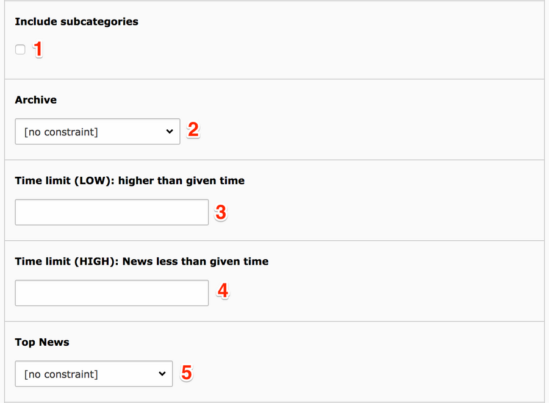3.3.2
Finally, on the 'Settings' tab, you will find the 'Startingpoint', where you select what folder in the page tree the news articles are stored in. Select the folder by clicking the 'Page' button (1) and in the page tree, presented in a popup, click the folder title where the newsa are stored, or by either searching for the page title in the search field. If you have mutliple folders containing news articles, you can continue adding by repeating the steps.
'Recursive:' (2) allows you to include subfolders, by setting number of levels in the dropdown. (img. 3.3.3)
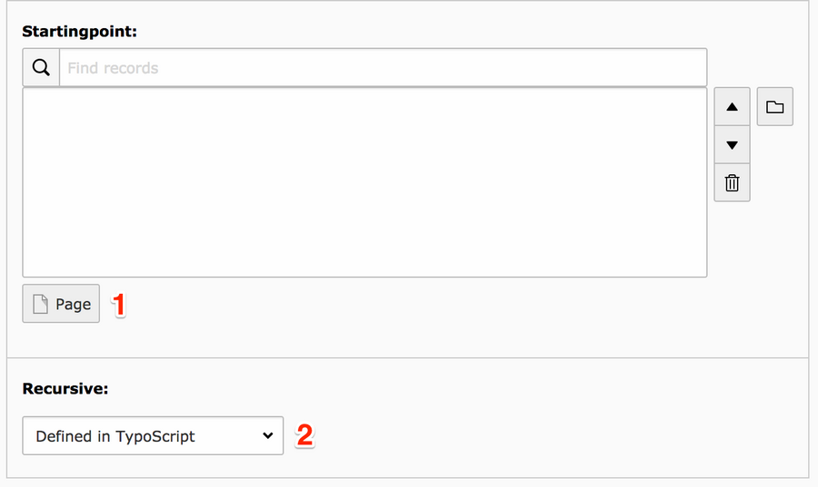3.3.3
Below the tab 'Additional' you have an option to select what page is used to display the detailed news article. Use the 'Page' button (1) to select the single view page from the page tree, or simply by searching for the page title in the search field. This setting applies when the plugin is set to show a list of news.
The second field on this tab, is applied when the plugin is using the different menu listings (categories, date, tags) to tell the plugin where it should display the result of clicking on a category, for example. Click the 'Page' button (2) to select which list-page should be used, or search for the page title in the search field. Note that this field is not used for the List view.
We have a field used when the plugin is set for detailed view of news article, to enable the option of returning to the list view. Use the 'Page' button (3) to select the list view page from the page tree, or simply by searching for the page title in the search field. Note that this field it not used for List view. (img. 3.3.4)
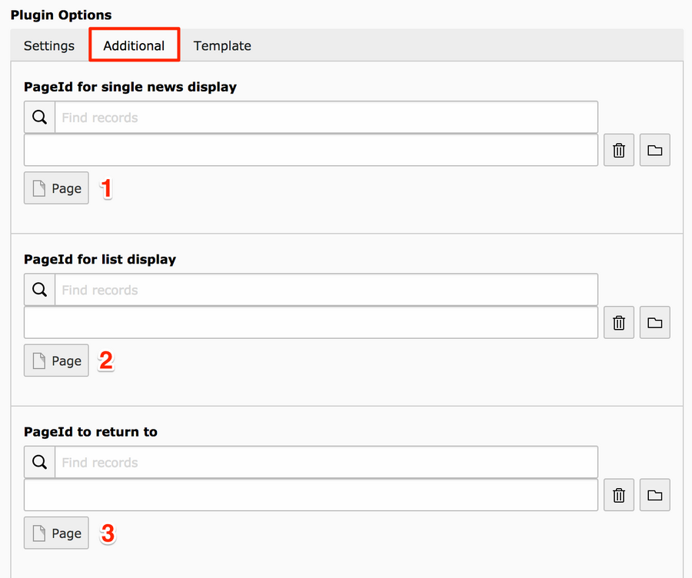3.3.4
When using the plugin to show a listing of news, it is possible to set how many news articles should be displayed (1). This can be used on the startpage, for example to only show the latest 4 news articles.
It is also possible to skip articles, and for example start showing from the second or third one. In the field (2) you will set 1 to start showing from the second one and 2 for showing from the third one, and so on. This function could be used to always show the first news article in a separate box (with the setting to only show one news article) and the rest in a regular listing.
You can select to only show news articles with specific tags. Select tags by either searching for the tag title in the search field, or by clicking the 'Tag' button (3) and selecting the news folder. There you will se a listing of all the tags.
After a set number of news articles, the plugin will automatically create a pagination. This feature can be hidden with the checkbox (4). (img. 3.3.5)

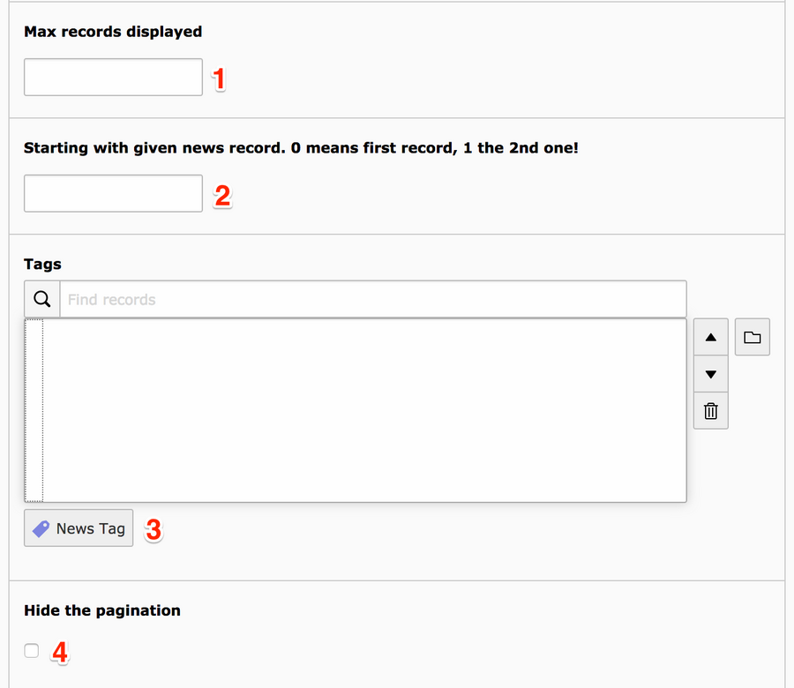3.3.5
'Items per Page' (1) allows you to set how many news articles should be shown before the automatic pagination kicks in, or to limit number of articles in the listing.
If you wish to able to push Top news before other news, this box should be checked (2), and selected news articles needs to be marked as well.
Within a session, for the visitors, viewed news articles can automatically be excluded from the list by checking this box (3).
The checkbox 'Disable override demand' (4) is used to override settings set in the general configuration for news plugins in the installation. (img. 3.3.6)
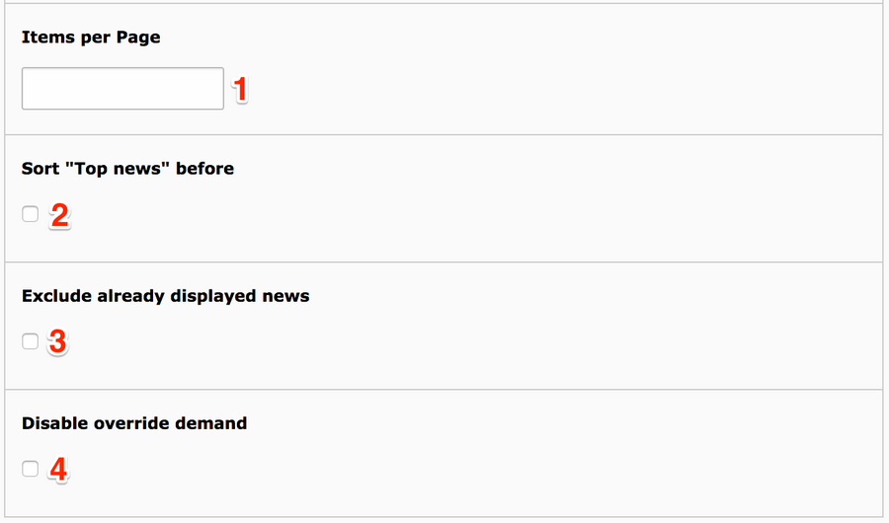3.3.6
The 'Template' tab contains settings for the max width (1) and height (2) of media placed in the template. Recommended is to leave these fields empty, and use the designed news template.
You can set a max length for the teaser (3), adding dots on the front of the website, if the teaser exceeds this length.
'Template layout' (4) contains available news templates, and the selection here depends on what templates has been implemented in the installation. (img. 3.3.7)
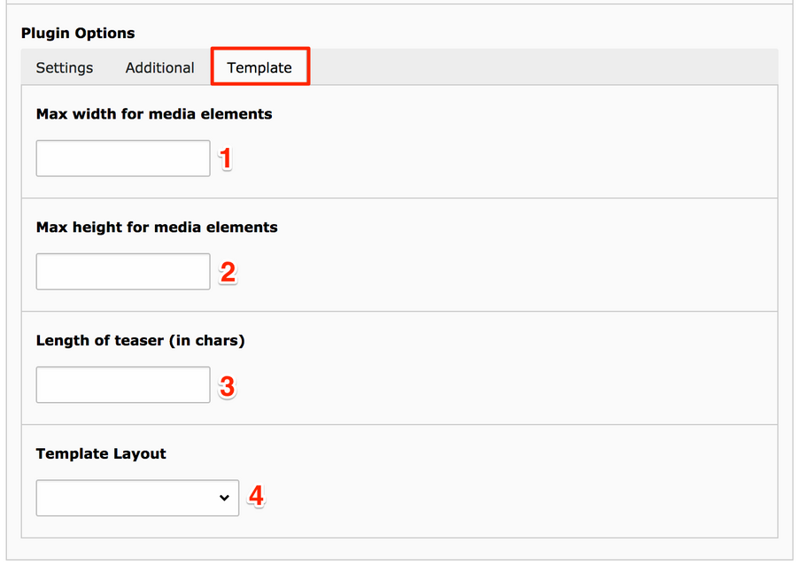3.3.7

3.4 Configuring the detailed view
Please read the section about page structure, before continuing.
After selecting 'Detail view' ('Plugin' --> 'Settings' tab) (1), the detailed view has an option to only show a selected news article (2), but normally this will be left empty. To select an article, use the search field or click the 'News' button, and then the news storage folder to find the available articles.
If you wish to able to preview hidden articles on the website, this option can be set to 'Yes' (3)
The 'Startingpoint', is where you select what folder in the page tree the news articles are stored in. Select the folder by clicking the 'Page' button (4) and in the page tree, presented in a popup, click the folder title where the newsa are stored, or by searching for the page title in the search field. If you have mutliple folders containing news articles, you can continue adding by repeating the steps.
'Recursive:' (5) allows you to include subfolders, by setting number of levels in the dropdown. (img. 3.4.1)
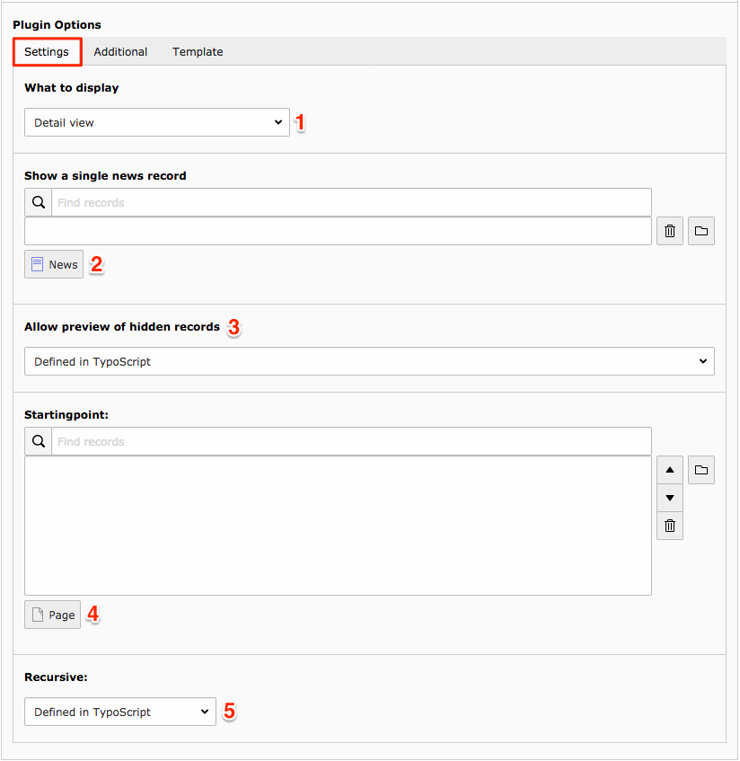3.4.1
Below the tab 'Additional' selection of what page is used to display the detailed news article (1) is not used.
'PageID to return to' (2) sets what page to return to the list view. Click the 'Page' button (2) to select which list-page should be used, or search for the page title in the search field above.
Selection to only show news articles with specific tags (3) is not used for the detailed view.
Exclusion of already viewed news articles (4), is not used in detailed view.
The checkbox 'Disable override demand' (5) is used to override settings set in the general configuration for news plugins in the installation. (img. 3.4.2)
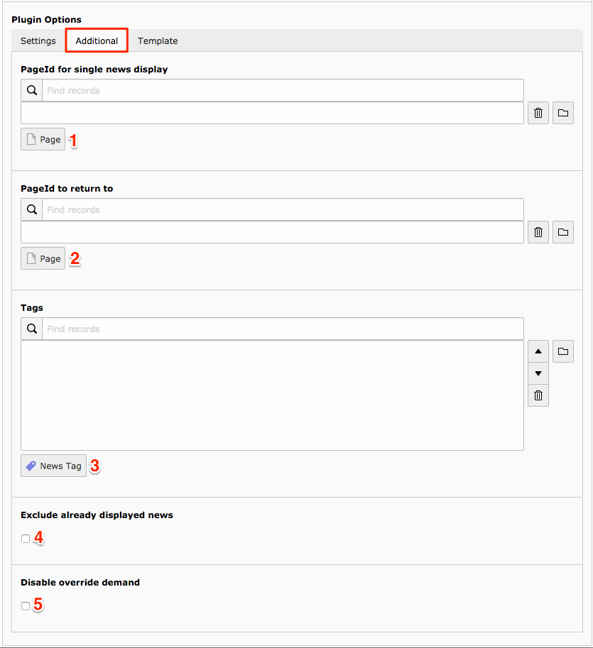3.4.2
The 'Template' tab contains settings for the max width (1) and height (2) of media placed in the template. Recommended is to leave these fields empty, and use the designed news template.
'Template layout' (3) contains available news templates, and the selection here depends on what templates has been implemented in the installation. (img. 3.4.3)
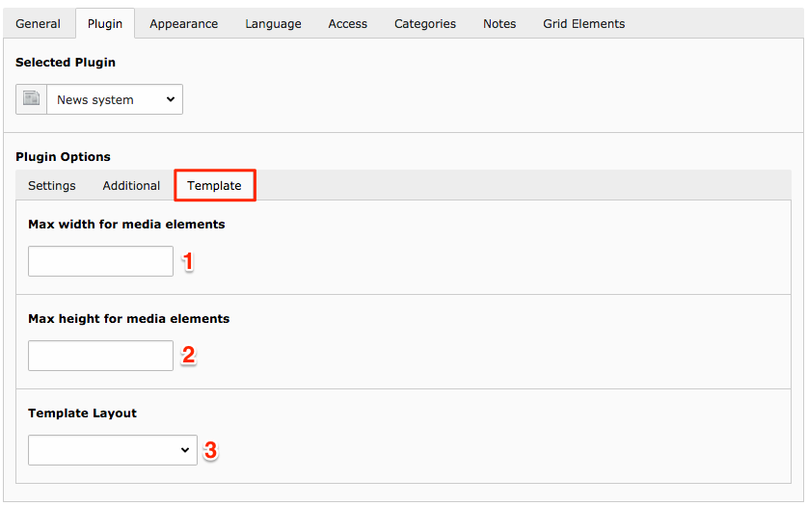3.4.3

