Setup Zimbra inbox
- Outlook
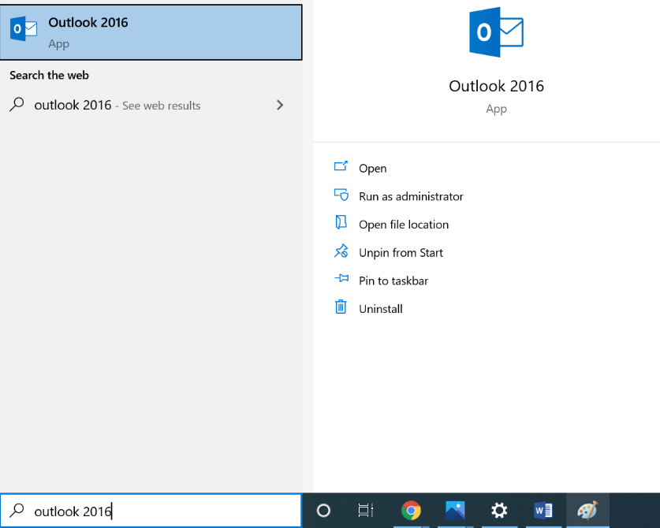

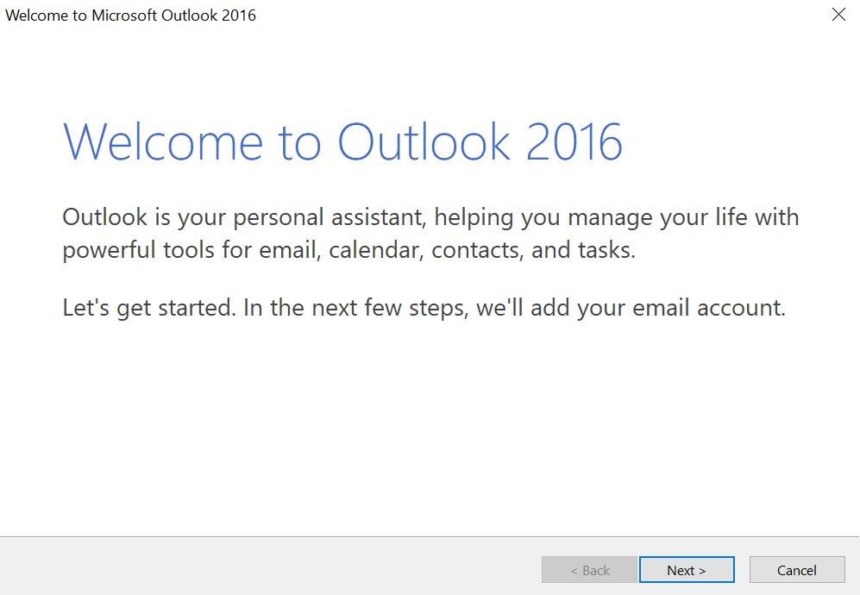
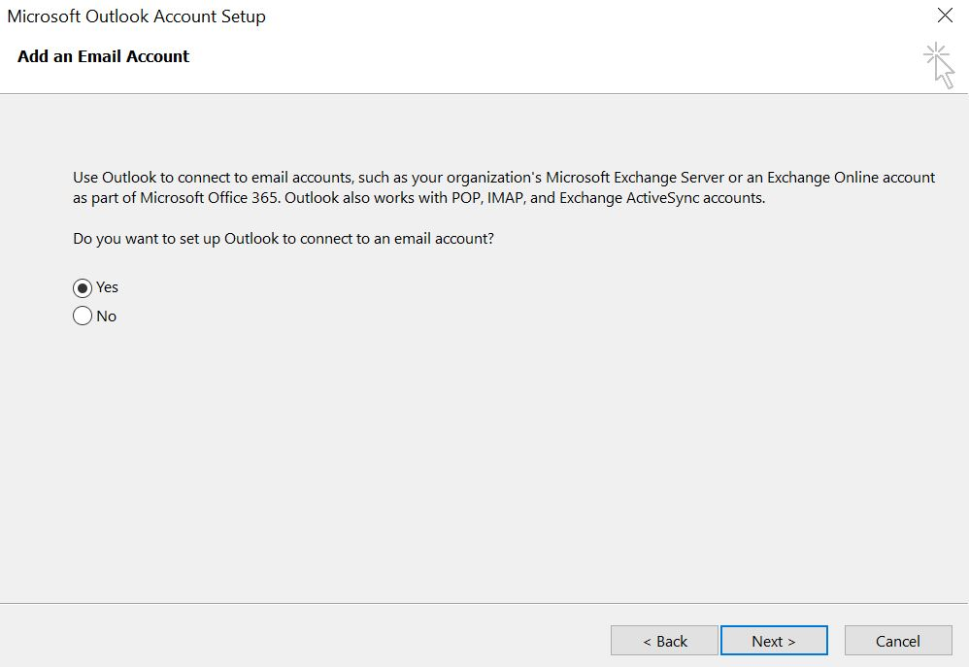
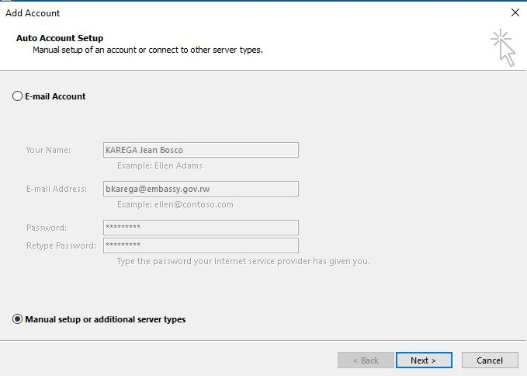
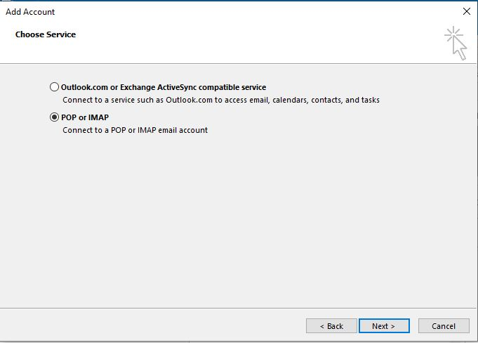
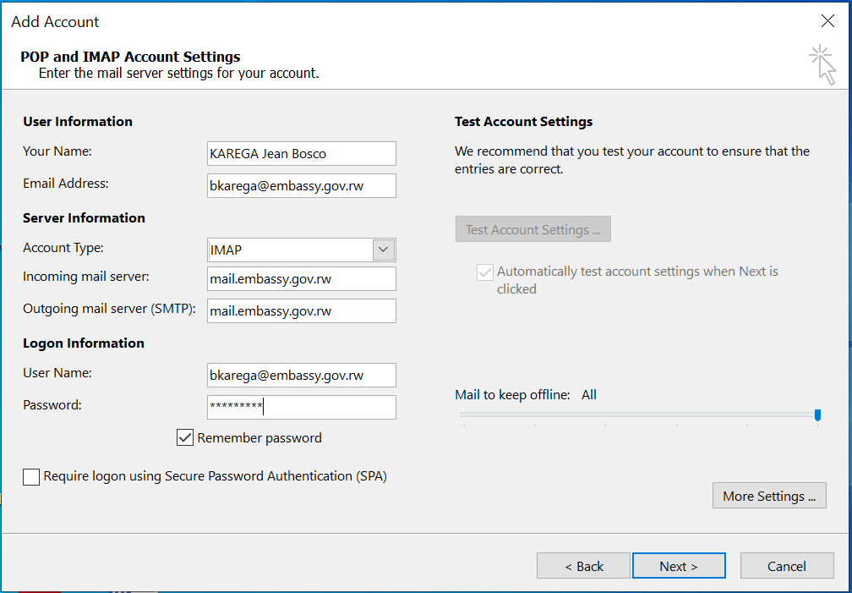
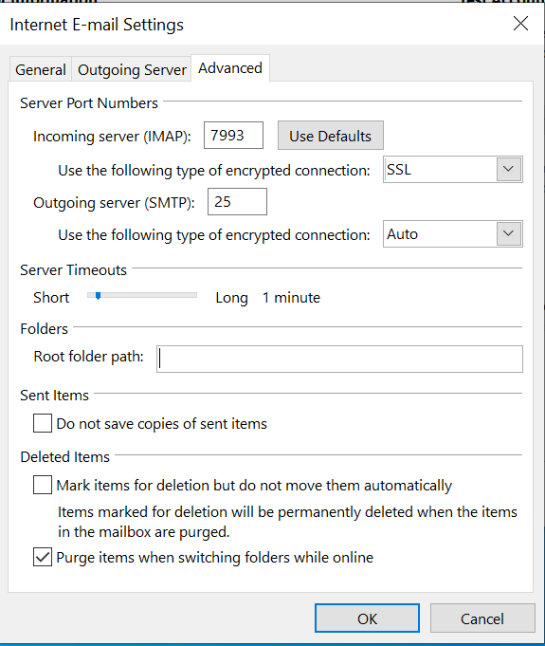

- Webmail
To access inbox, please visit https://mail.embassy.gov.rw:8443
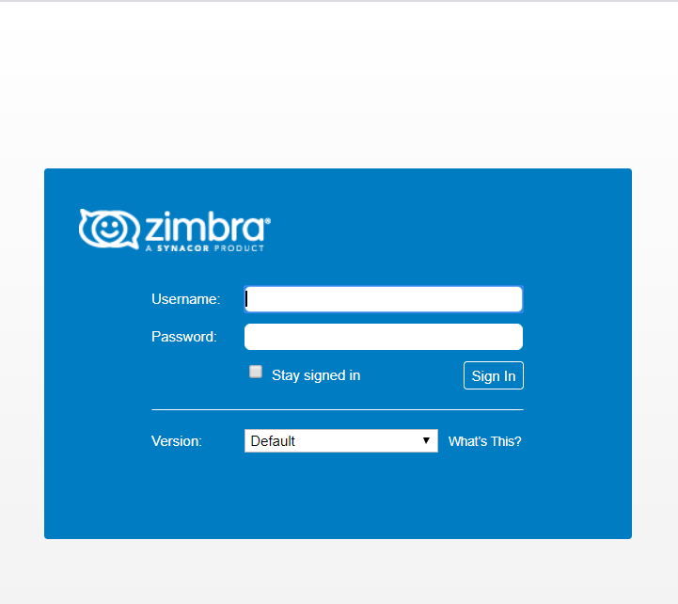

- Mobile
Incoming mail server: mail.embassy.gov.rw
Security: SSL
Incoming port: 7993

Outgoing mail server: mail.embassy.gov.rw
Security: STARTTLS
Outgoing port: 587

- Accessing admin panel

Kindly browse: https://mail.embassy.gov.rw:7071/
Login using admin@embassy.gov.rw

- Adding members to a group email
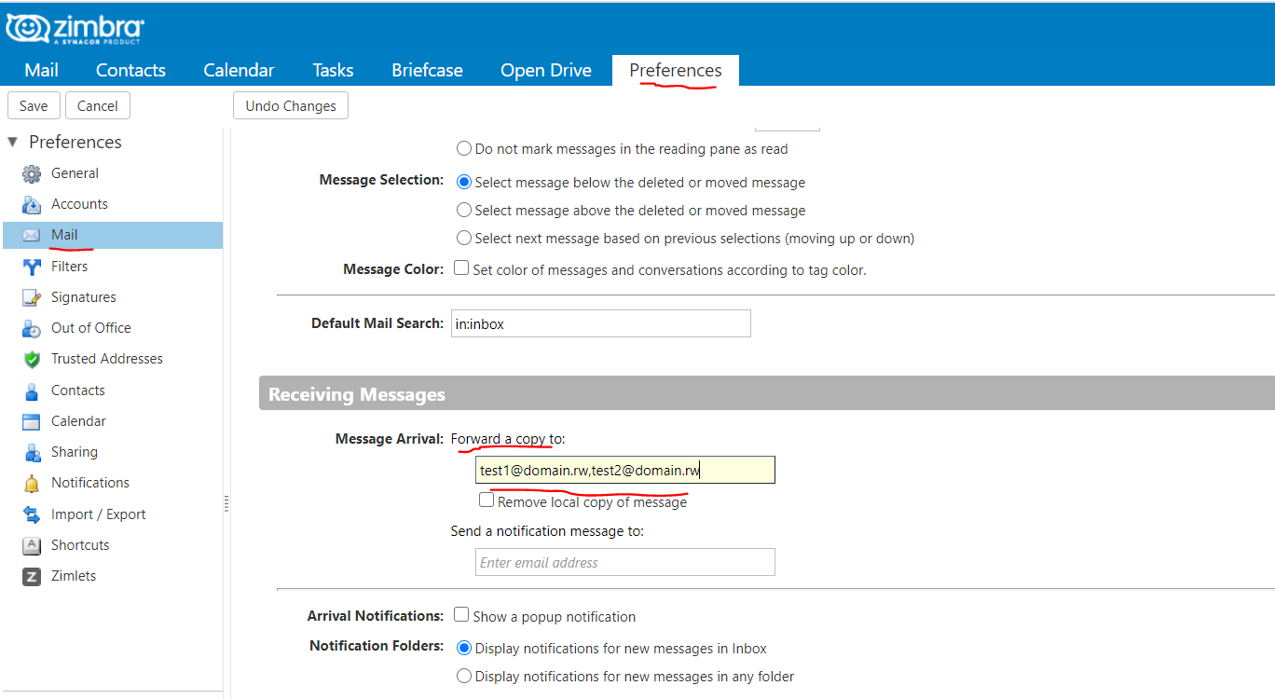
Once in the inbox of the group email, go to Preferences – Mail – Forward a copy to the people’s email separated by comma. Finally, click on save on the top left.

